# **Lab 0: Setting up the lab environment**

**Objective:** In this lab, you will acquire a Power Apps trial license and create a team in Microsoft Teams.

## **Exercise 1: Assign a Power Apps trial license**

1. Open a web browser on your VM and go to +++<https://powerapps.microsoft.com/en-us/free/>+++.

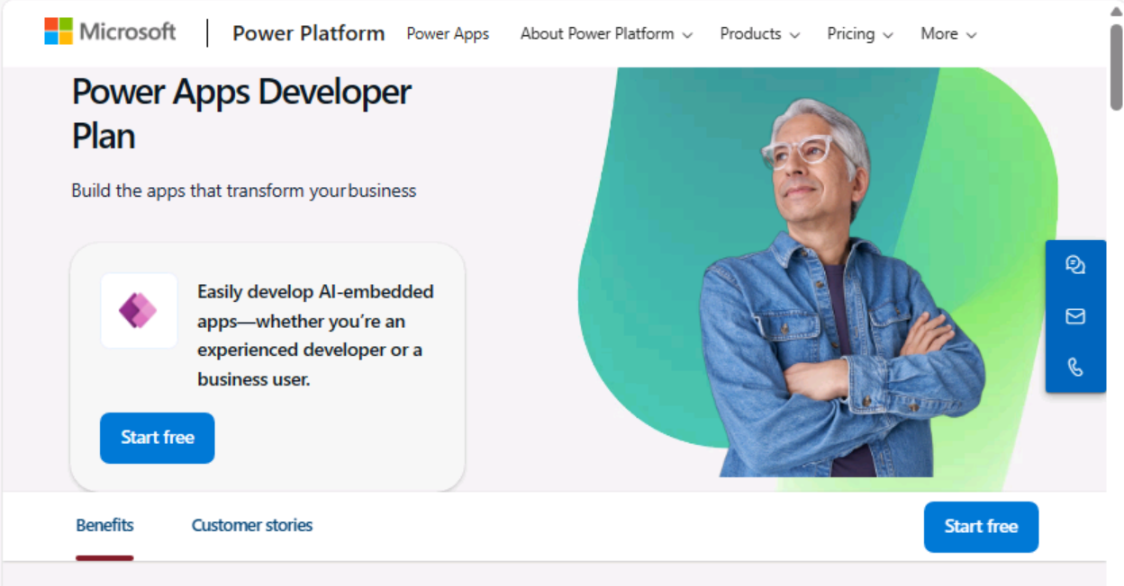

1. Select **Start free**.

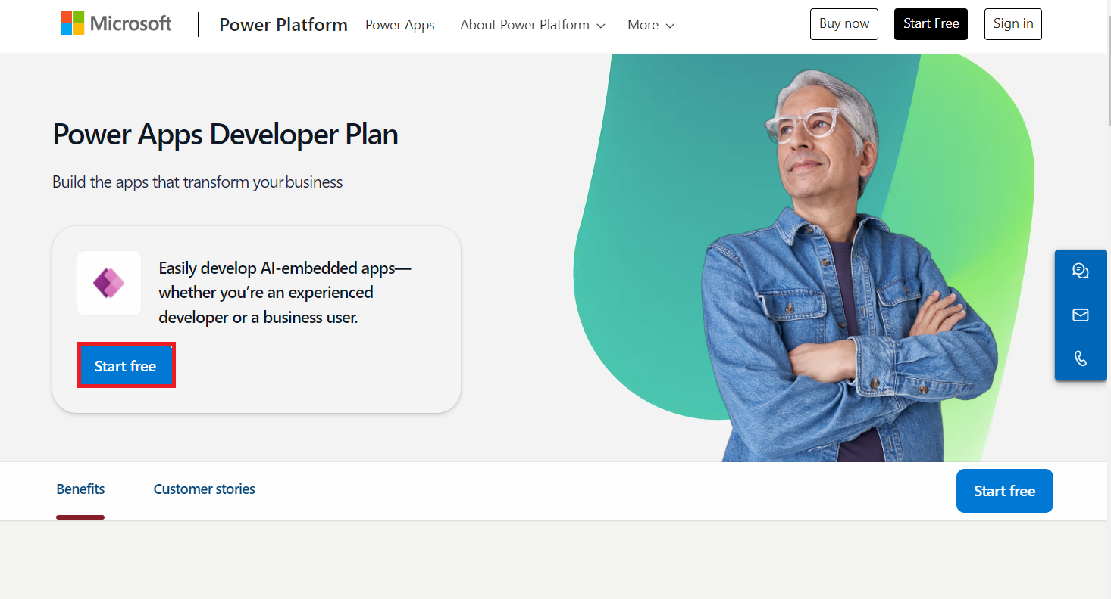

1. Enter your **Office 365 admin credentials**, check the checkbox to **accept the agreement,** and click on **Start free**.

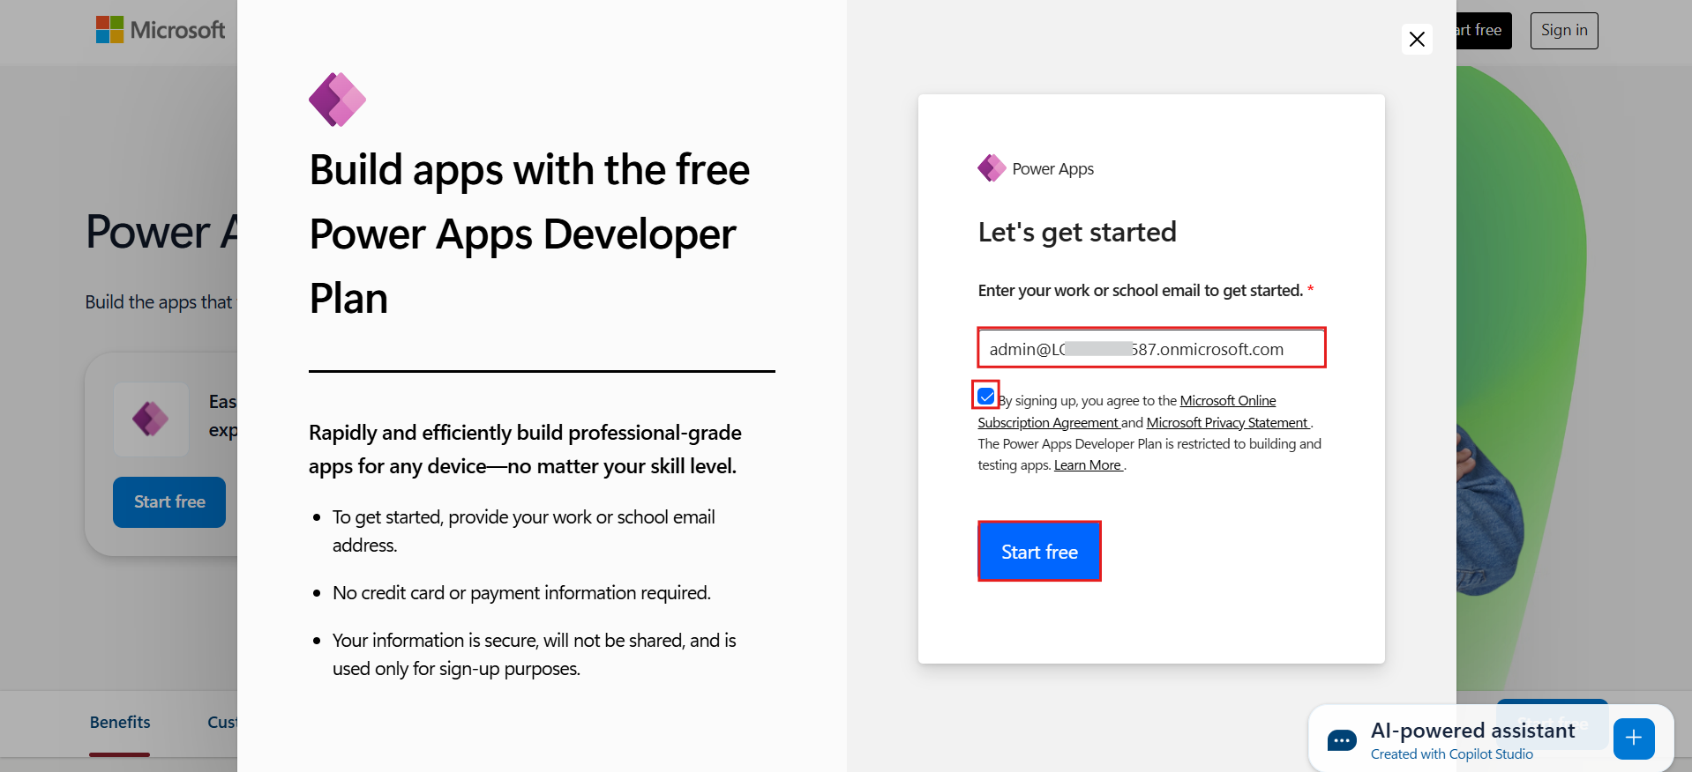

1. Enter the **password of your Office 365 tenant id** and then select **Sign in**.

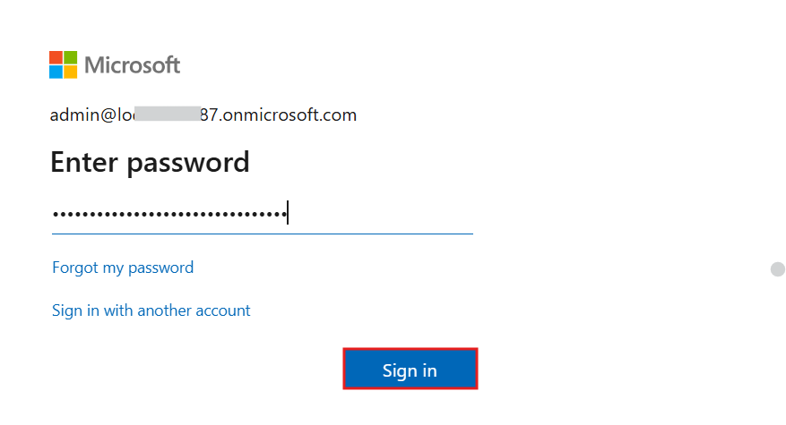

1. Select **Yes** on **Stay signed in?** pop-up window.

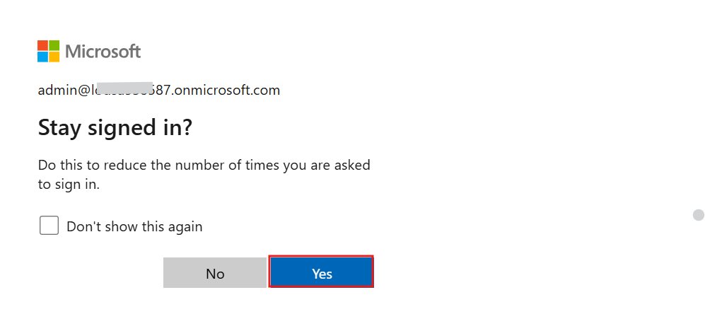

1. Keep the **United States** as your **country/region** and then click on the **Get started** button.

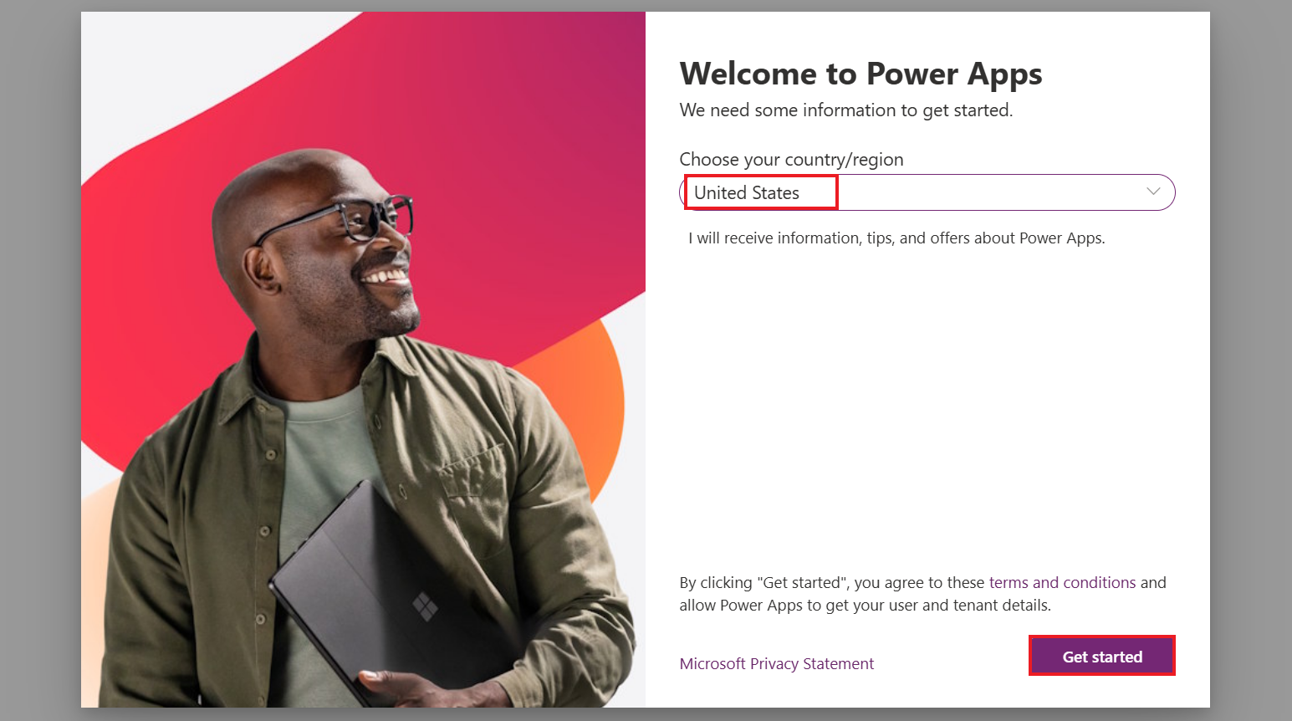

1. You can now see the **Home page of Power Apps** and the developer environment – **Dev One,** which has been created for you.

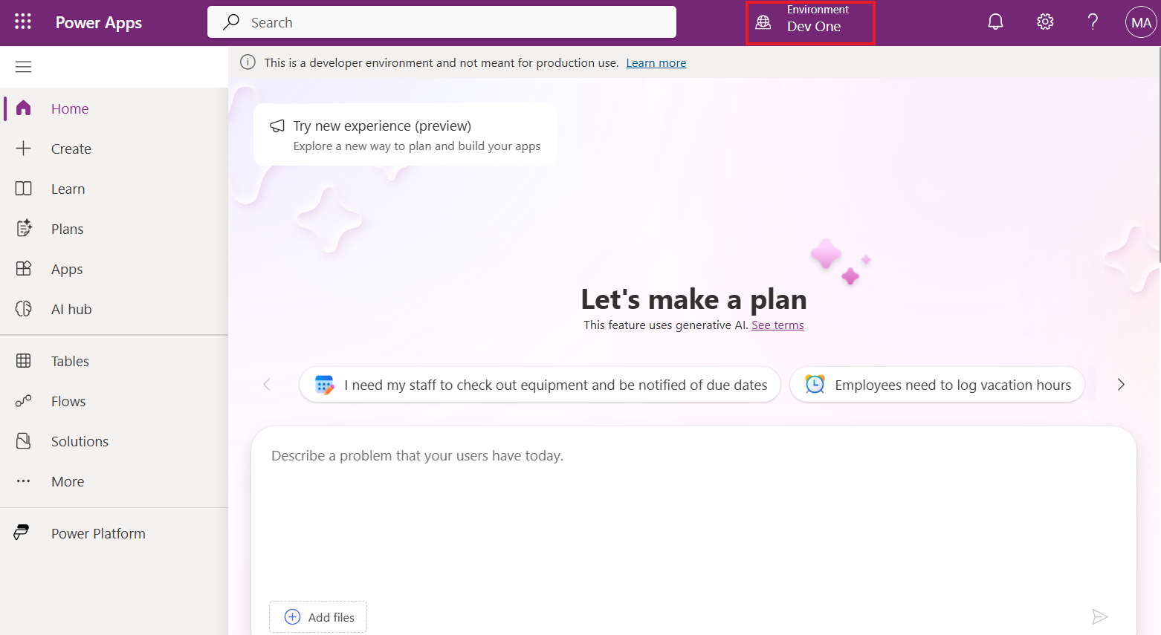

1. Open the new tab and go to the **Power Platform admin center** by navigating to [https://admin.powerplatform.microsoft.com,](https://admin.powerplatform.microsoft.com) and if required, sign in using your given Office 365 admin tenant credentials.

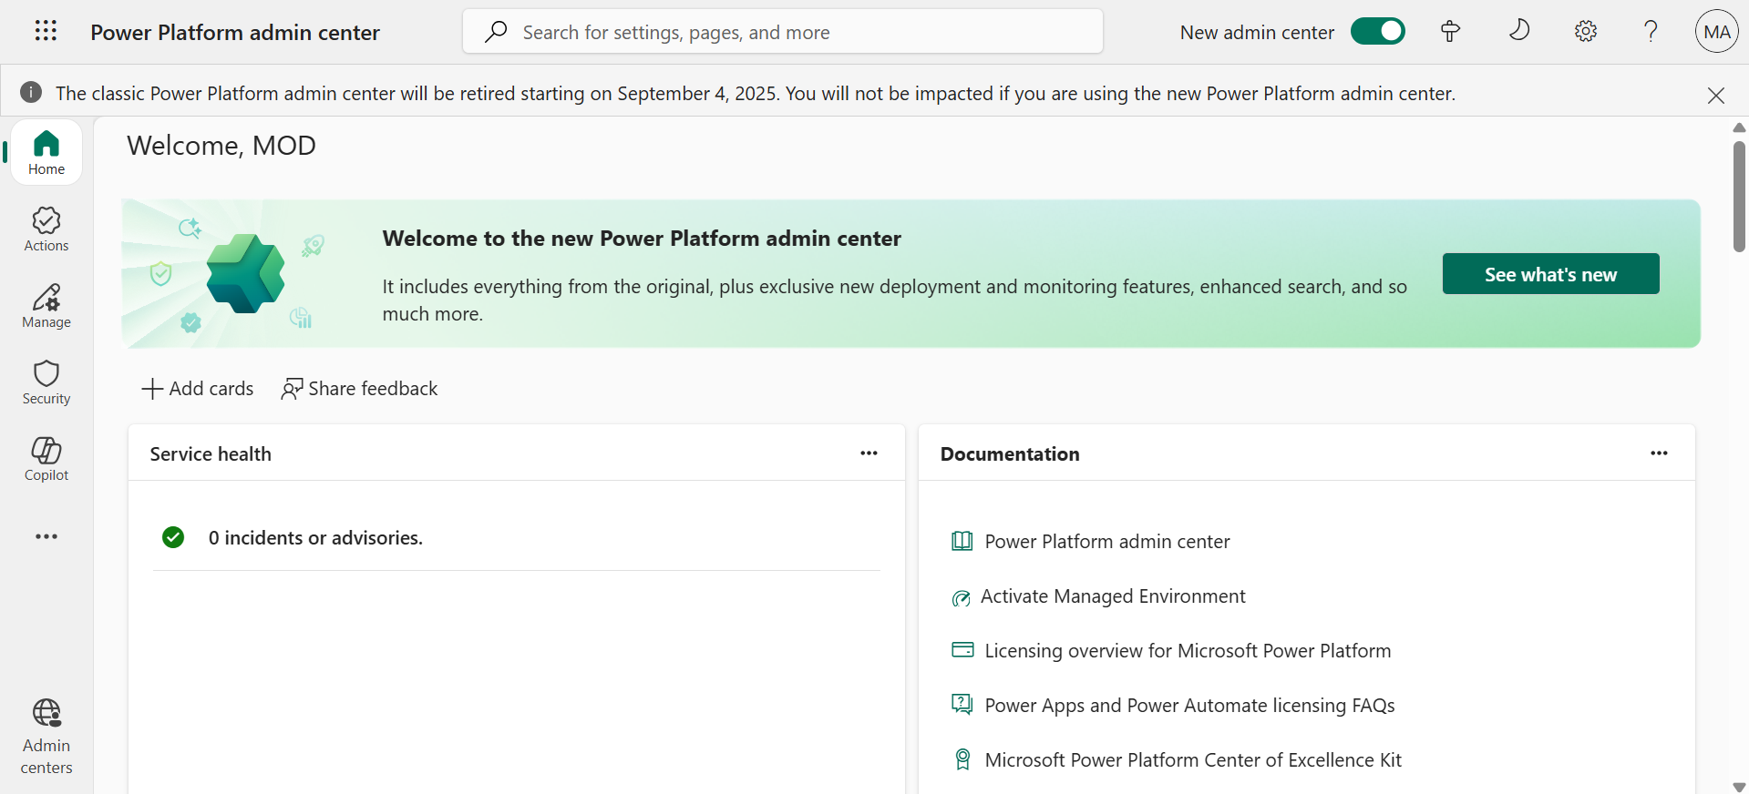

1. From the left navigation pane, select **Manage** > **Environments,** and then you can see that **Dev One** is your Dataverse environment.

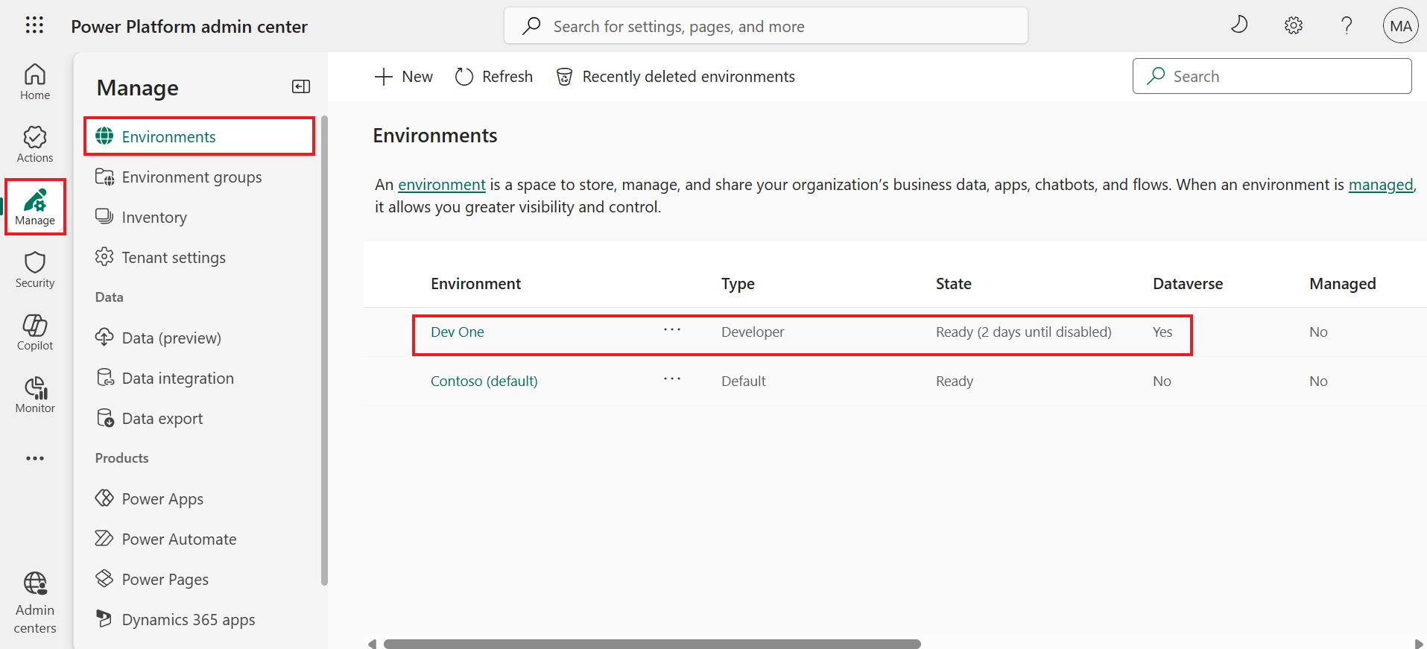

## **Exercise 2: Create a team in Microsoft Teams**

**Task 1: Create a team in Microsoft Teams**

1. Sign in to Microsoft Teams using [**https://teams.microsoft.com/**](urn:gd:lg:a:send-vm-keys) with your Office 365 tenant credentials.
2. On the **Get to know Teams** pop-up window, select **Get Started**.

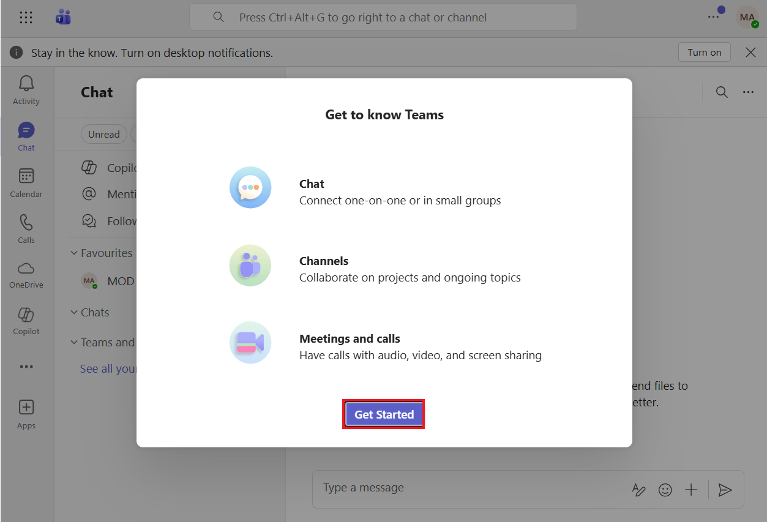

1. Close the window that asks for scanning the QR code.

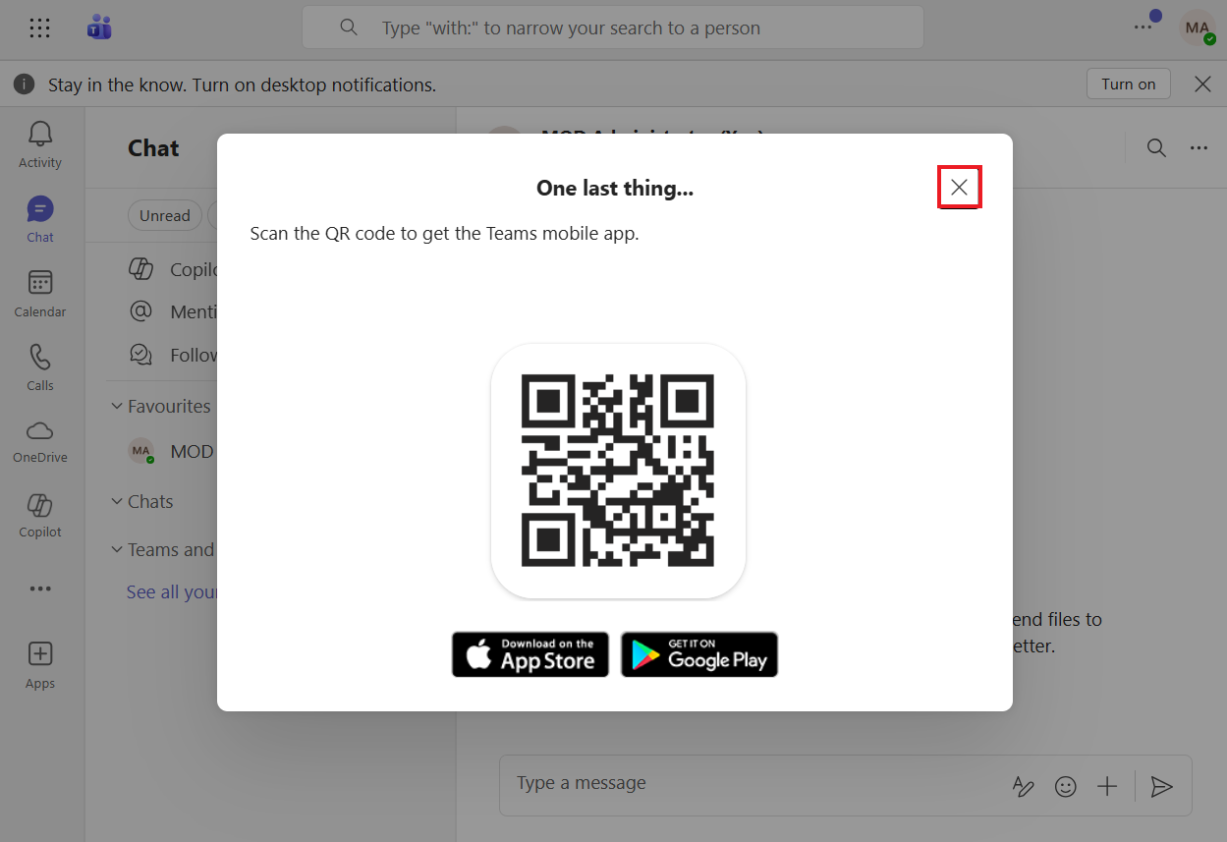

1. On the left side of the app, select **Chat**.

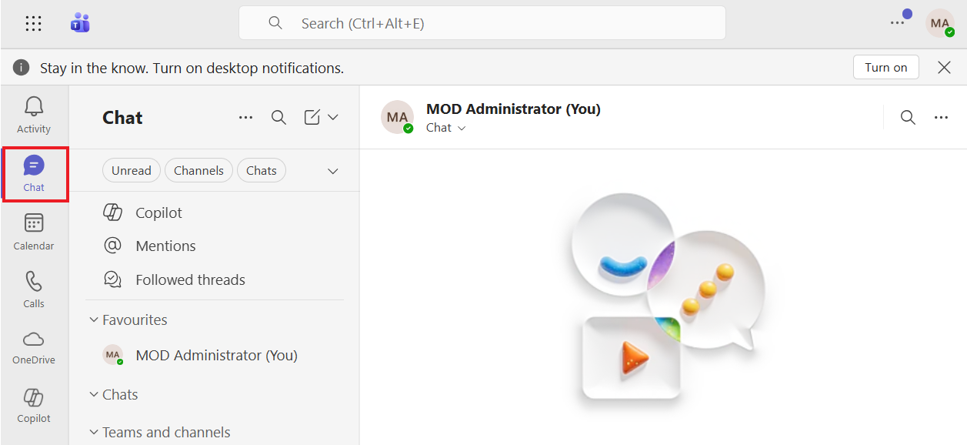

1. Select **New items** from the Chat section. Select **New team**.

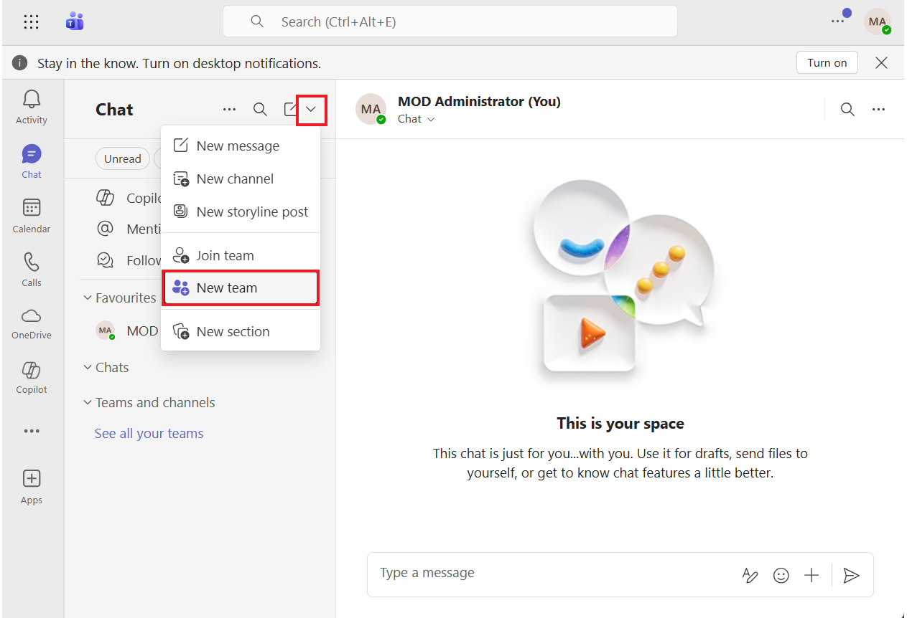

1. Enter the Team name as **Dev Team,** First channel name as **DevChannel,** and click **Private**.

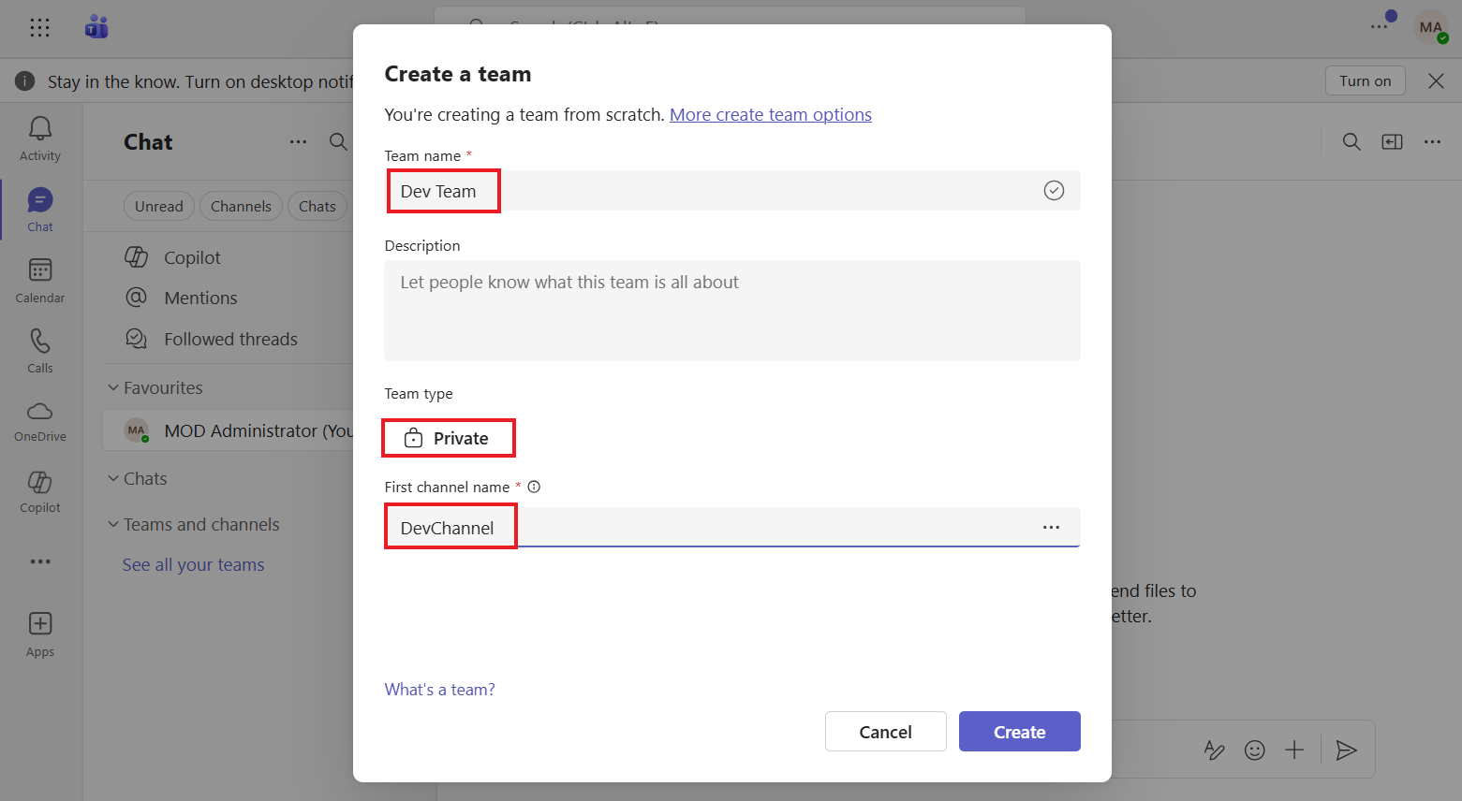

1. Select **Org-wide**.

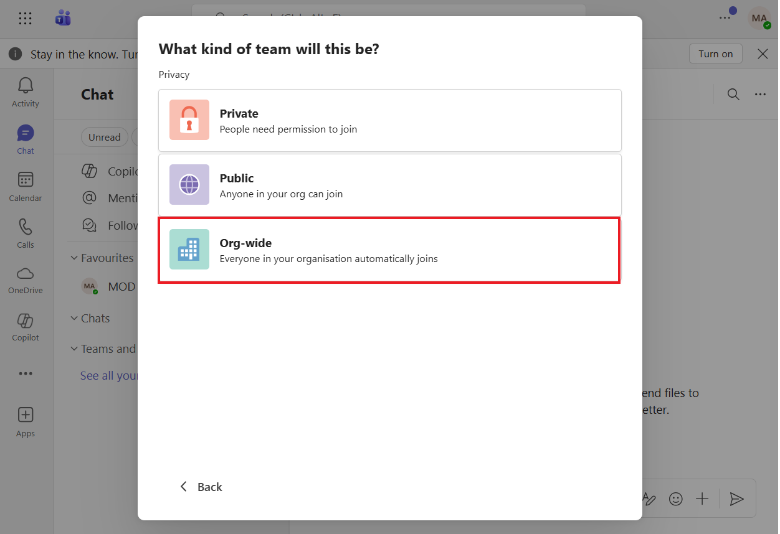

1. Select **Create**.

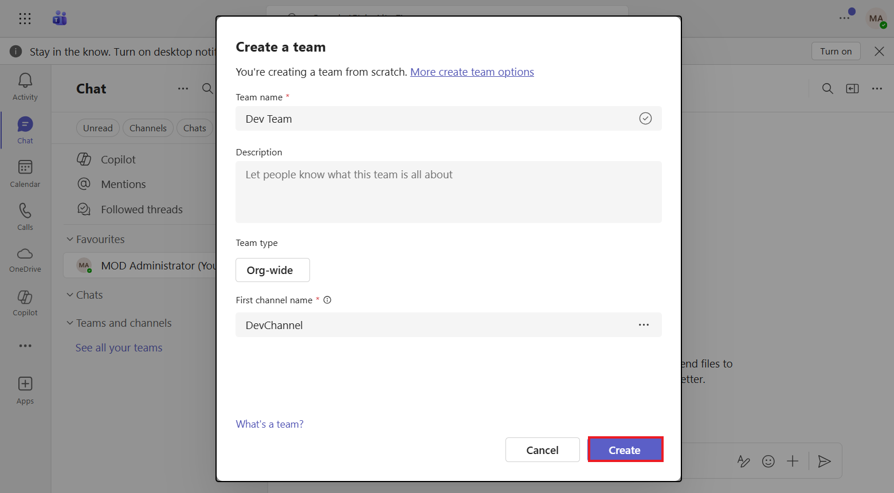

1. You can now see the **Test** team has been created.

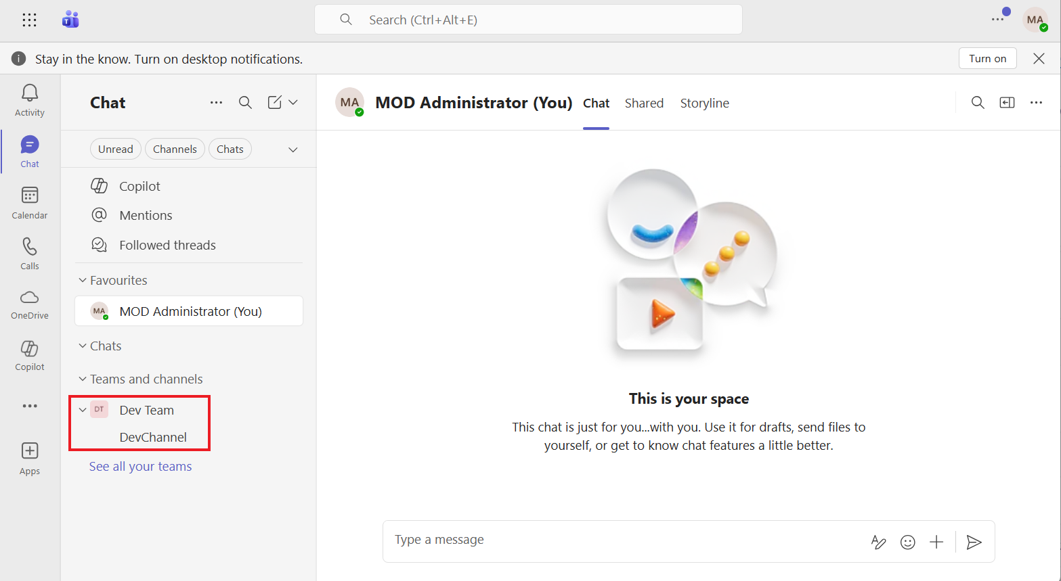

**Task 2: Enable Transcription in Teams**

1. Sign in to the **Microsoft Teams admin center** [**https://admin.teams.microsoft.com/dashboard**](urn:gd:lg:a:send-vm-keys).
2. Expand the left navigation pane and select **Show all**.

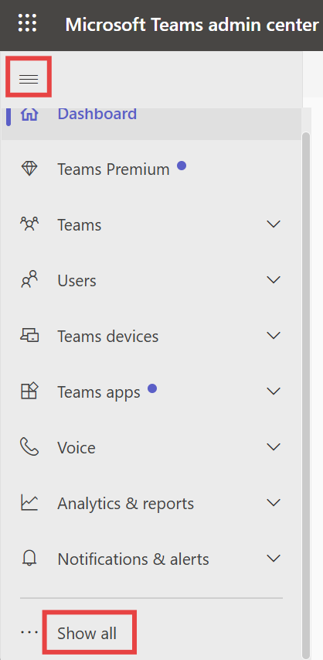

1. Select **Meetings > Meeting policies**.

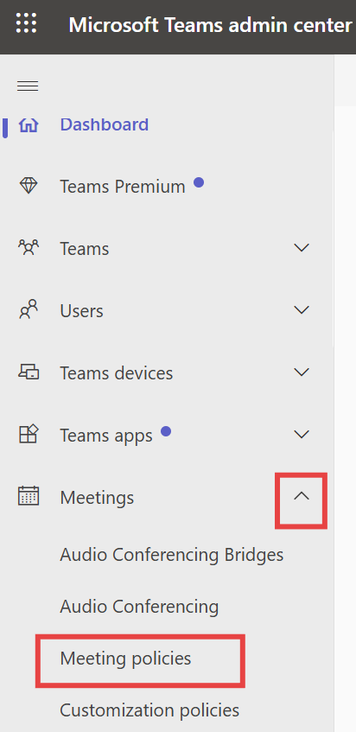

1. Select **Global (Org-wide default) policy** under **Manage policies** tab.

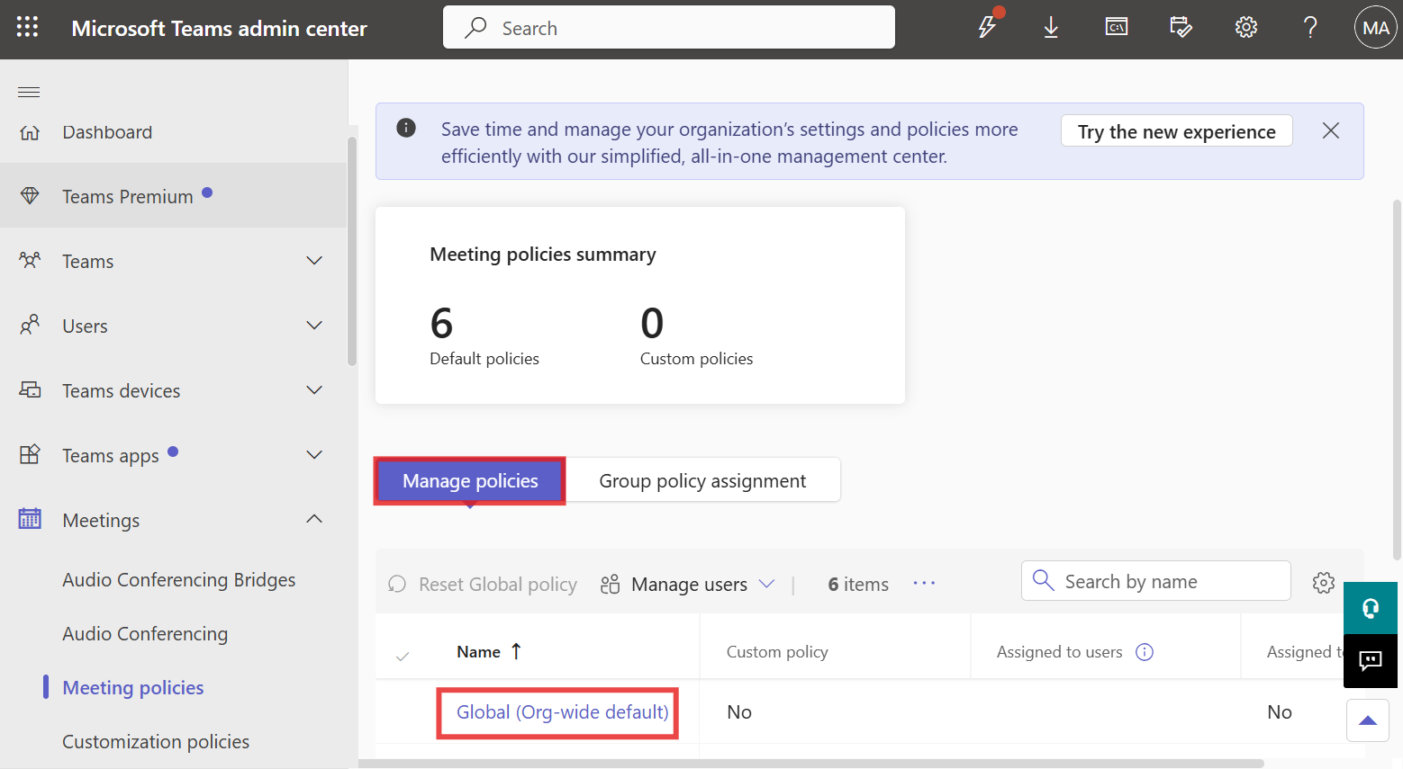

1. Under **Recording and transcription** section, Make sure **Transcription** button is **On**. If not, make it on and then select **Save**.

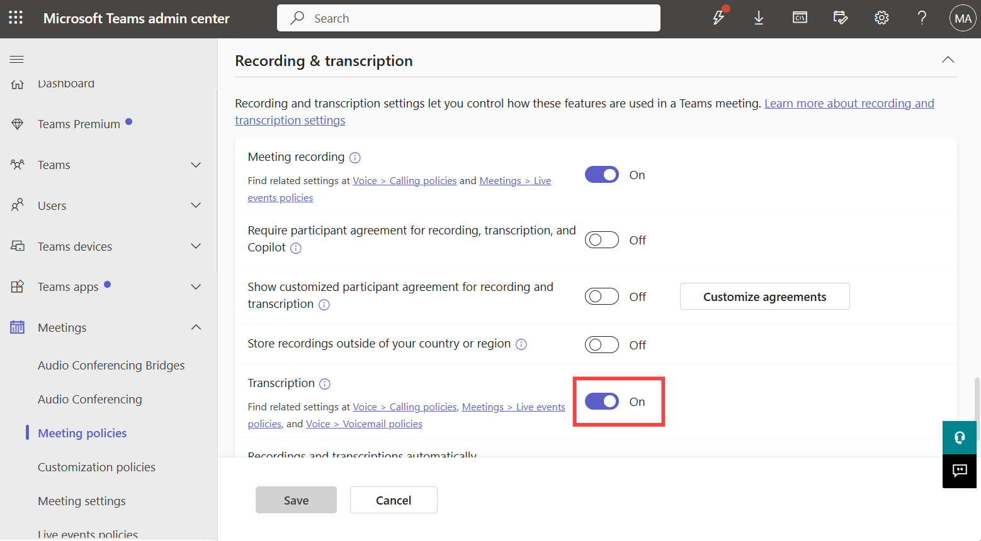

1. Select **Confirm** if you have made changes.

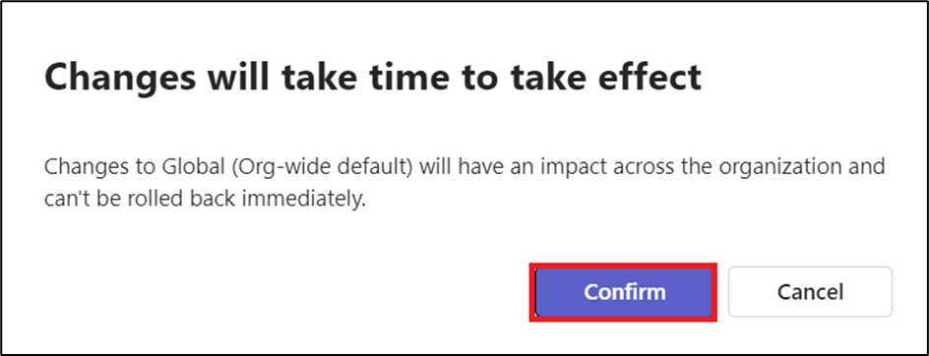

1. From the left navigation pane, select **Live events policies** under **Meetings**. Select **Global (Org-wide default) policy**.

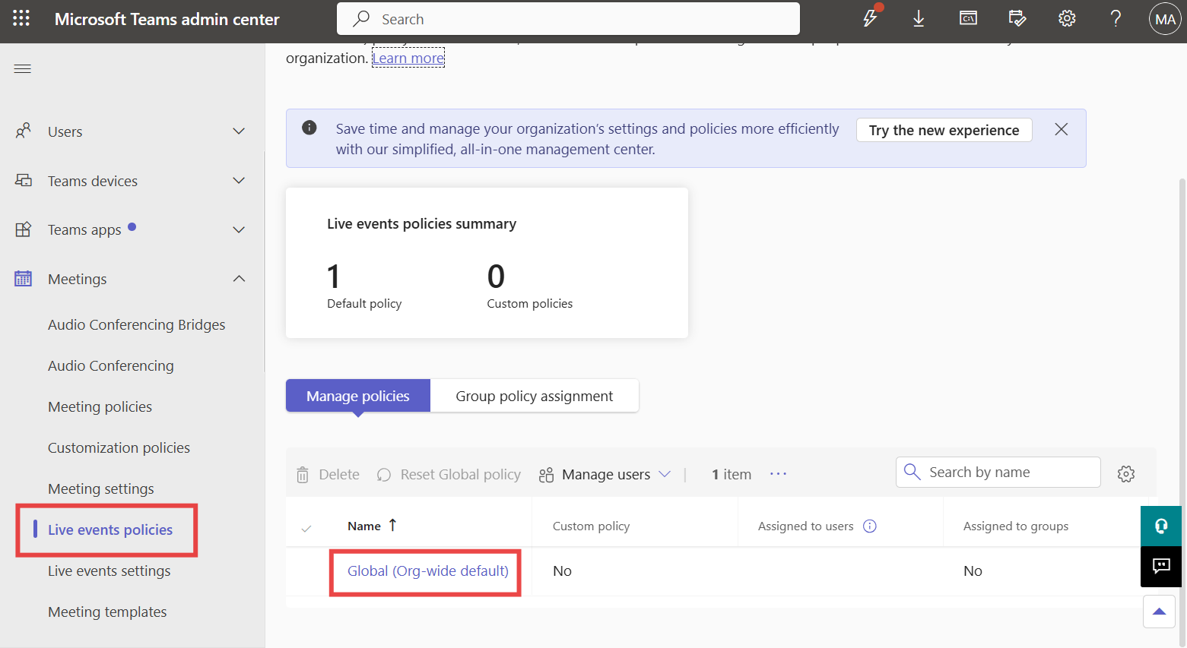

1. Toggle the button for **Transcription for attendees** to **On** and then select **Save**.

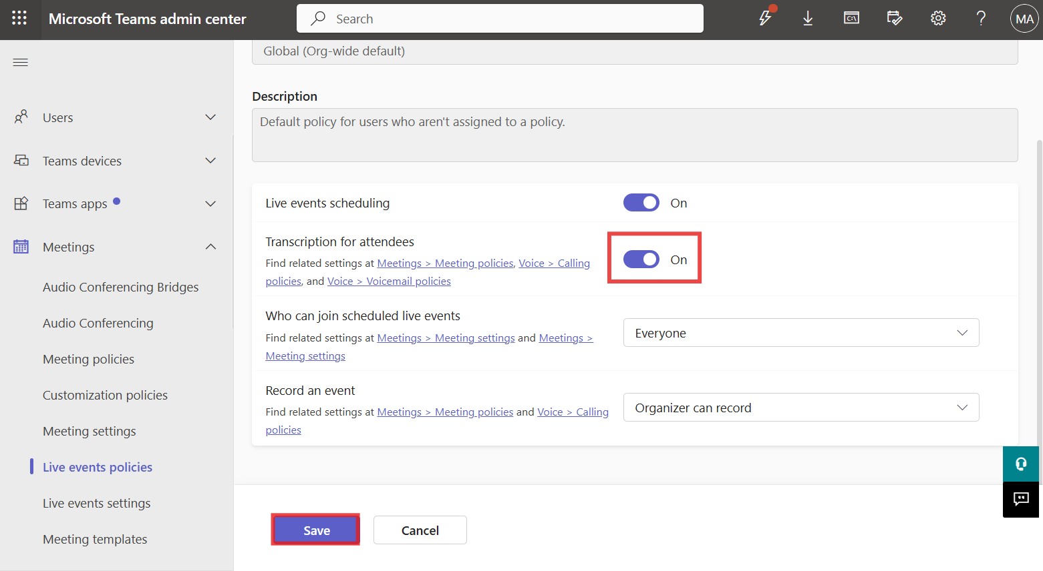

1. Select **Confirm** to make changes.

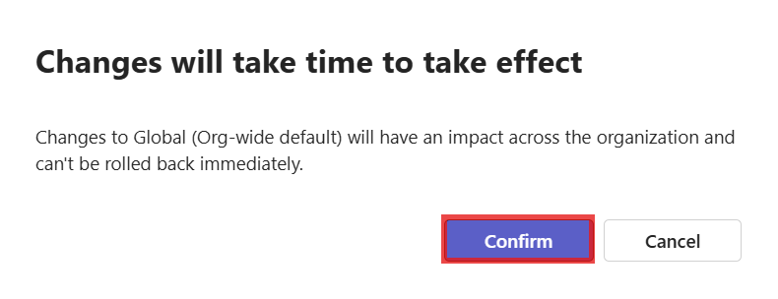

1. From the left navigation pane, under **Voice**, select **Calling policies**. Select **Global (Org-wide default) policy**.

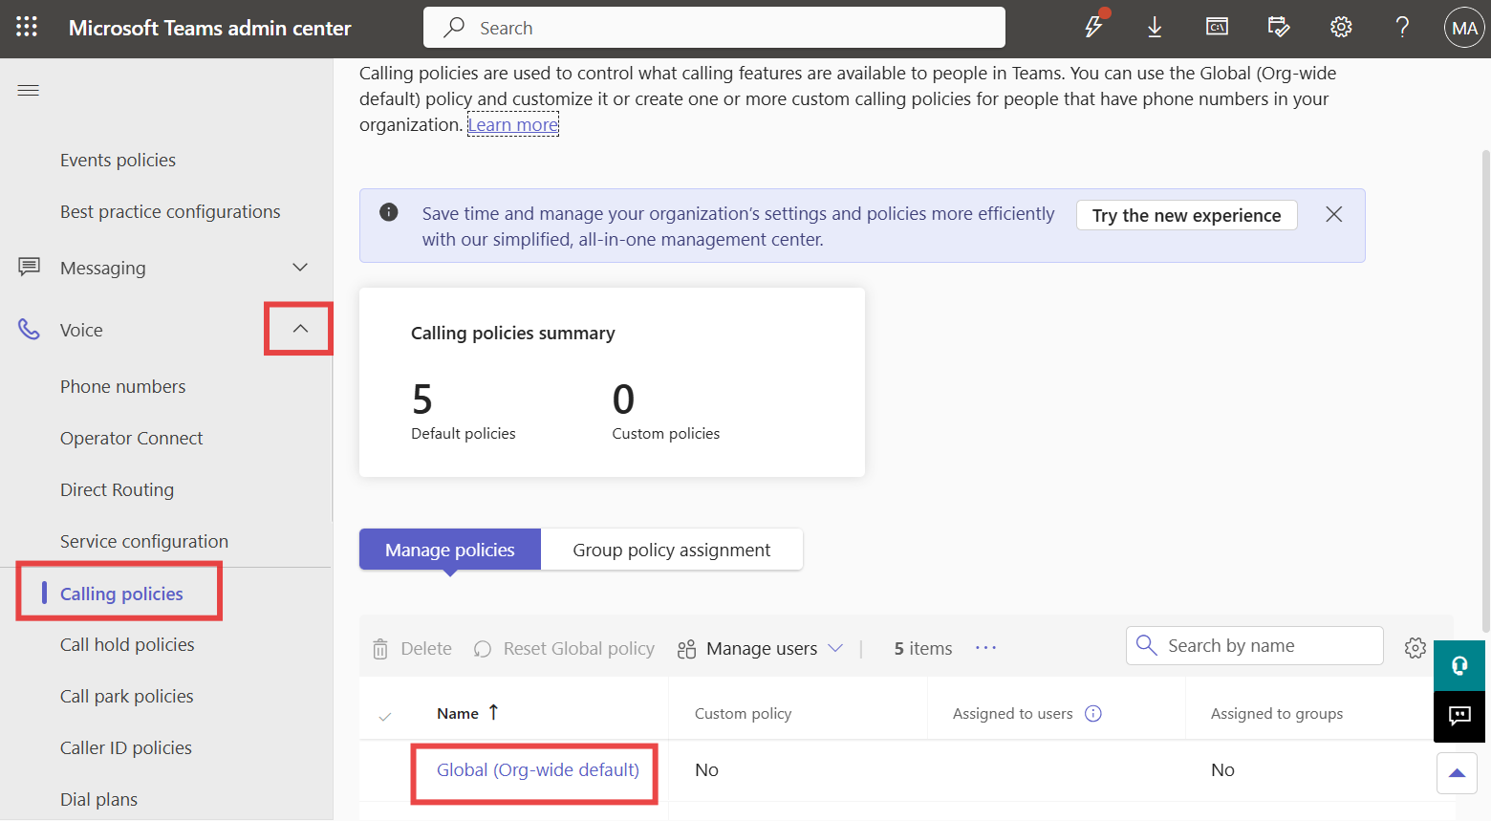

1. Toggle **Transcription** to **On** (if not) and then select **Save**.

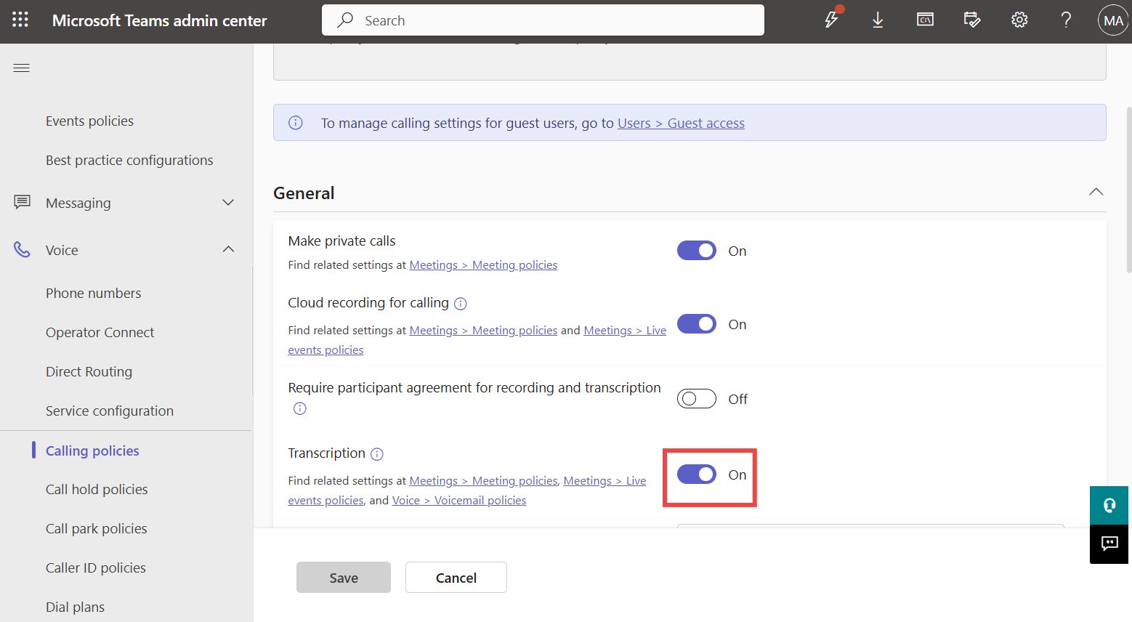

1. Select **Confirm** to make changes.

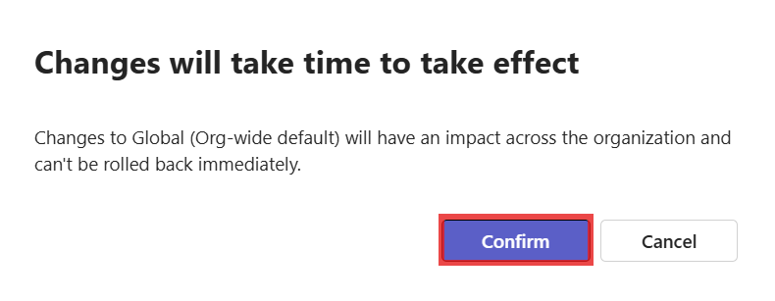

1. From the left navigation pane, under **Voice**, select **Voicemail policies**. Select **Global (Org-wide default) policy**.

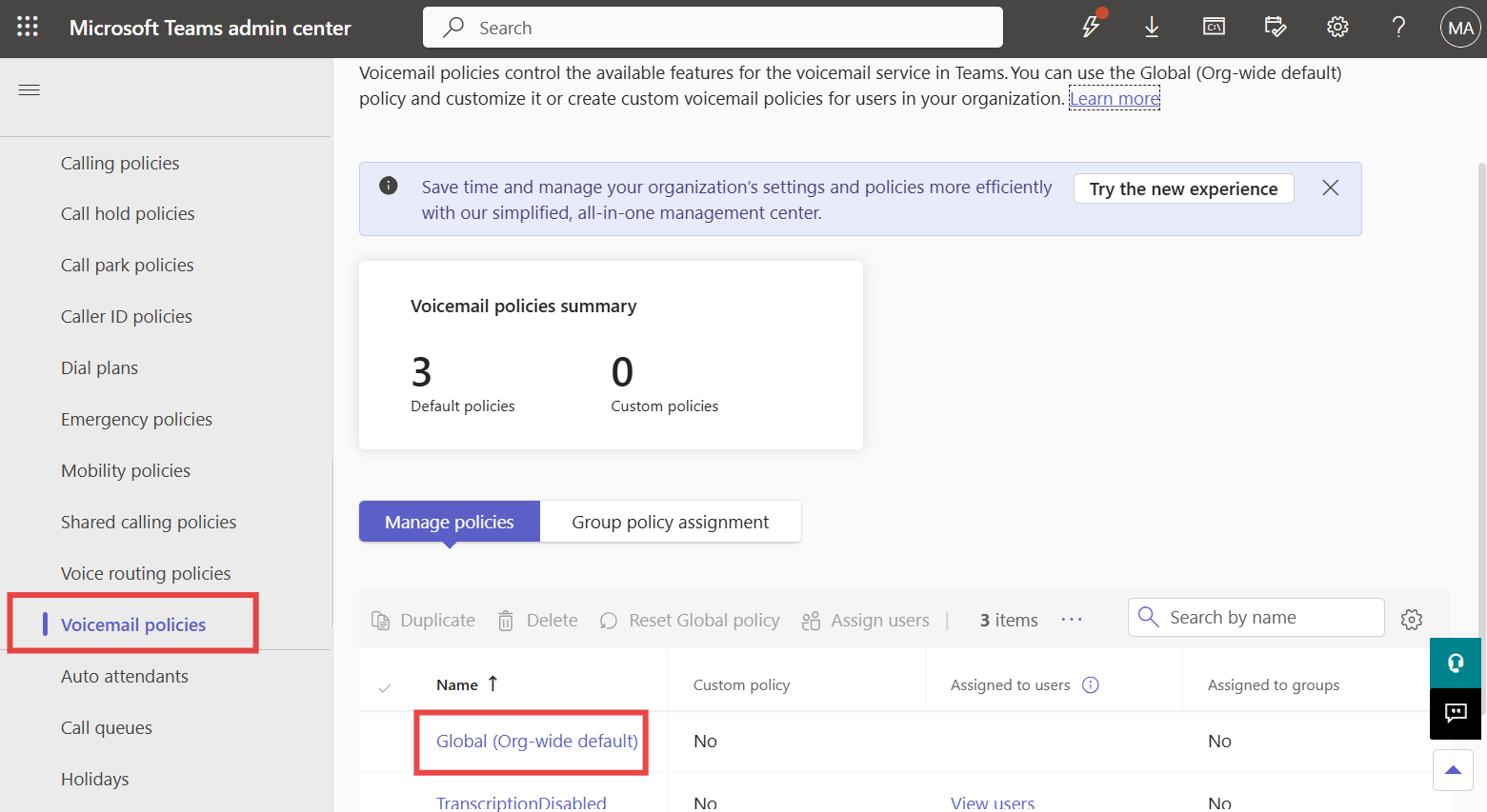

1. Toggle **Mask profanity in voicemail transcription** to **On** and then select **Save**.

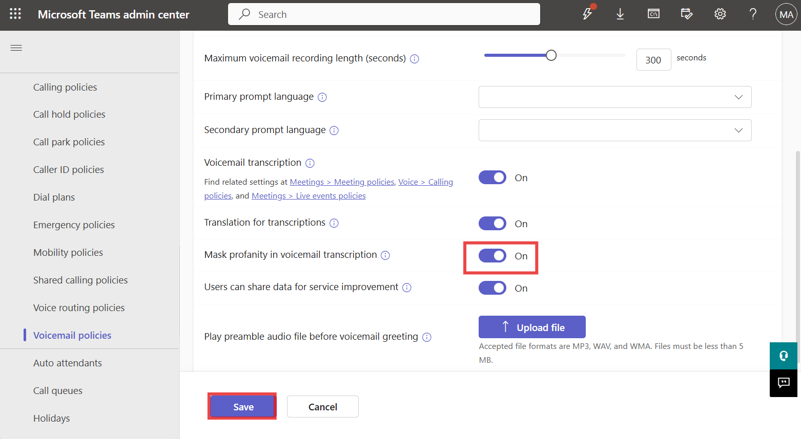

1. Select **Confirm** to make changes.



## **Exercise 3: Assign a Customer Service trial license and enable Copilot**

**Task 1: Assign Customer Service trial license**

1. Open your browser and browse to [**https://dynamics.microsoft.com/en-in/customer-service/overview/**](urn:gd:lg:a:send-vm-keys) and select **Try for free**.

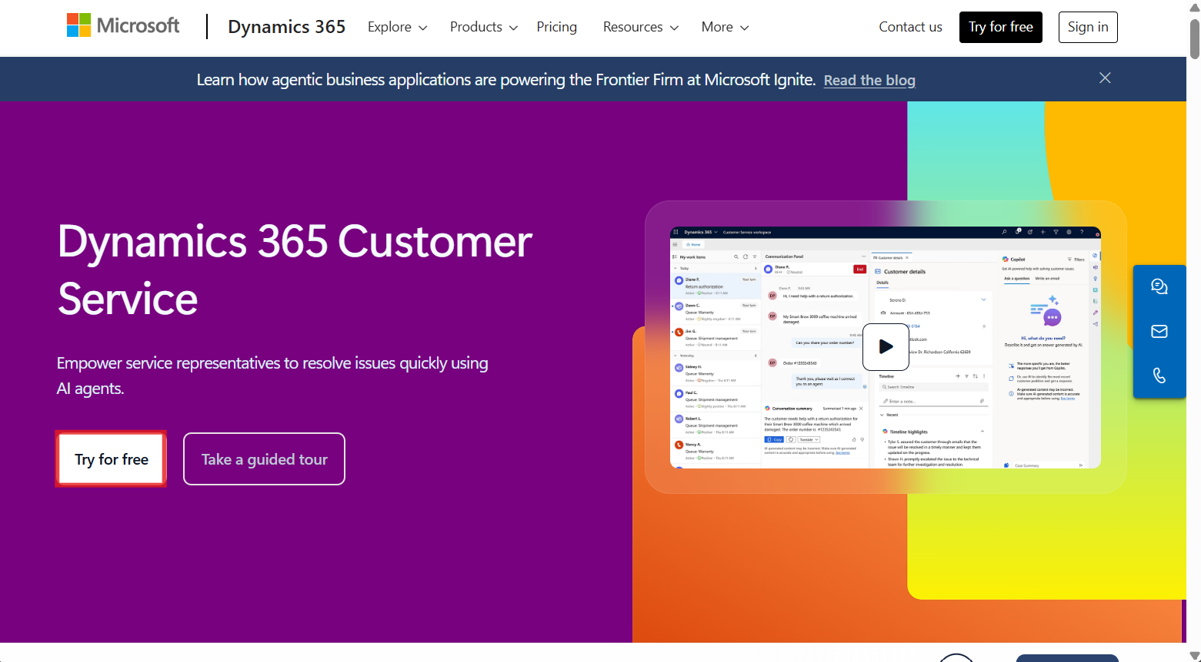

1. Enter your **Office 365 admin tenant credentials**, select the checkbox to **accept the agreement** and click on **Start your free trial**.

[**admin@M365xXXXXXX.onmicrosoft.com**](urn:gd:lg:a:send-vm-keys)

[**MyAdminPassword**](urn:gd:lg:a:send-vm-keys)

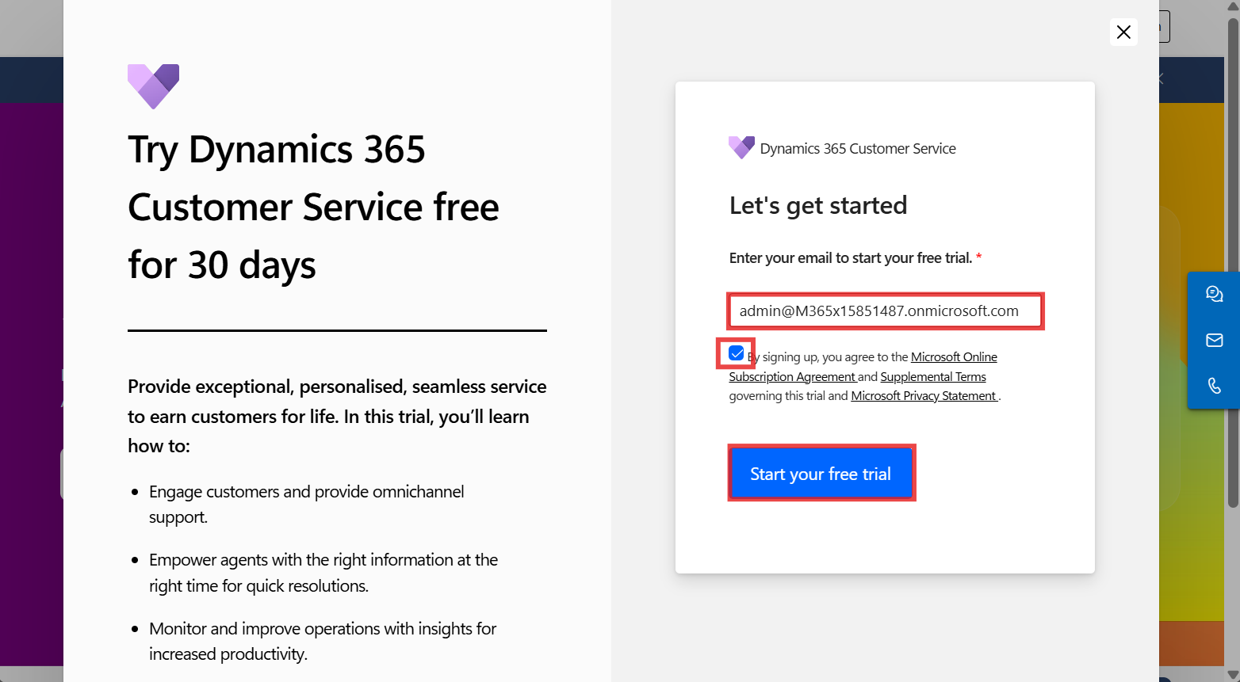

1. Provide **Contact Information** as below and then select **Submit**.

**Job Title**: Your job title

**Country/region**: United States

**Phone number**: Your phone number

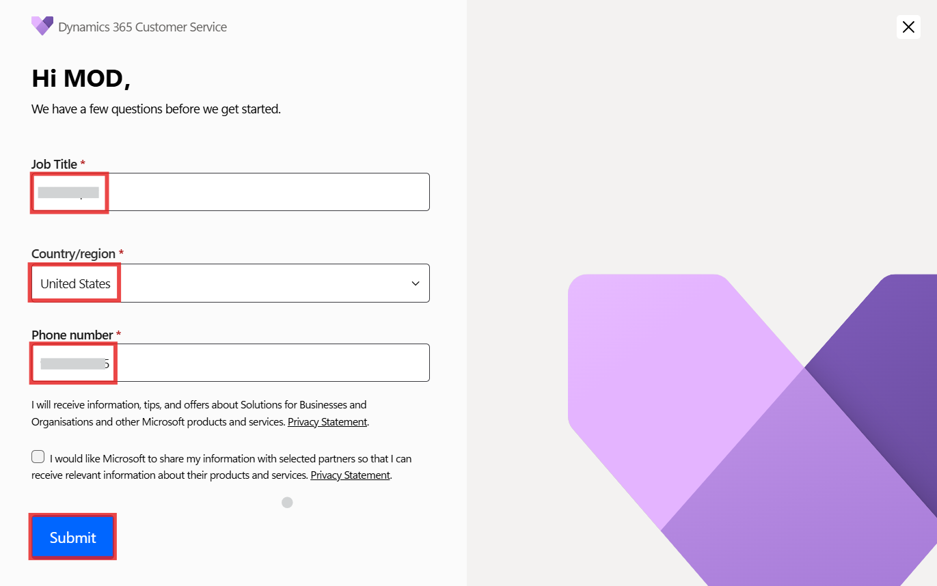

1. If asked, enter your **Office 365 admin tenant password**.

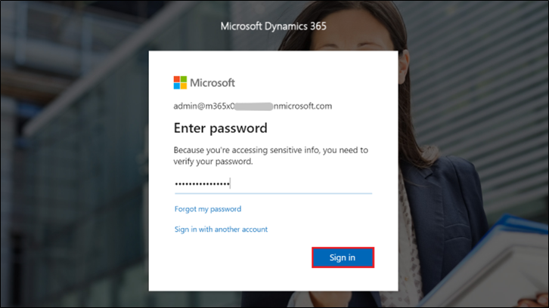

1. You will land on the **Copilot Service Workspace** portal.

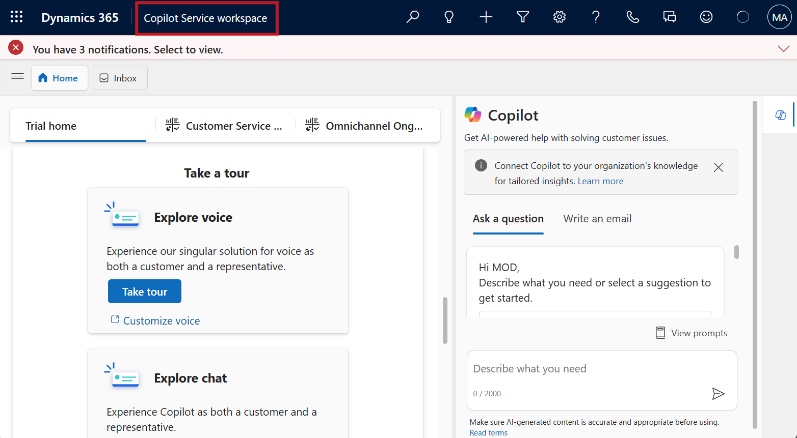

1. Go to **Power Platform admin center** by navigating to [**https://admin.powerplatform.microsoft.com/**](urn:gd:lg:a:send-vm-keys) and if required, sign in using your given **Office 365 tenant admin** credentials. From the left navigation pane, select **Manage** > **Environments** and then you can see, **Customer Service Trial environment** is created.

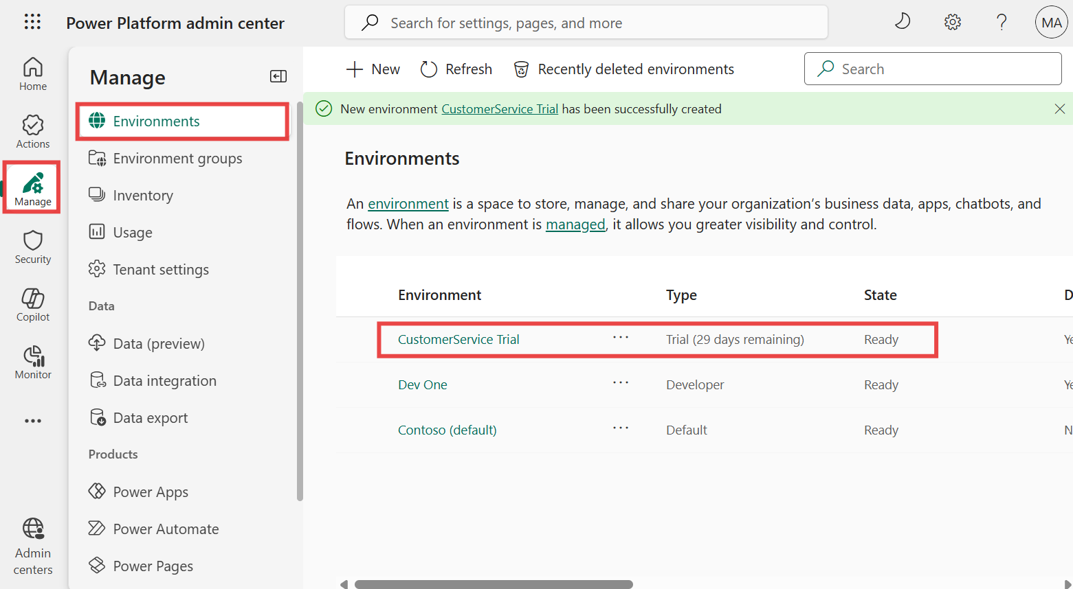

**Task 2: Enable the Copilot feature**

1. Navigate back to the **Copilot Service workspace portal**. Select the **Copilot Service workspace** at the top.

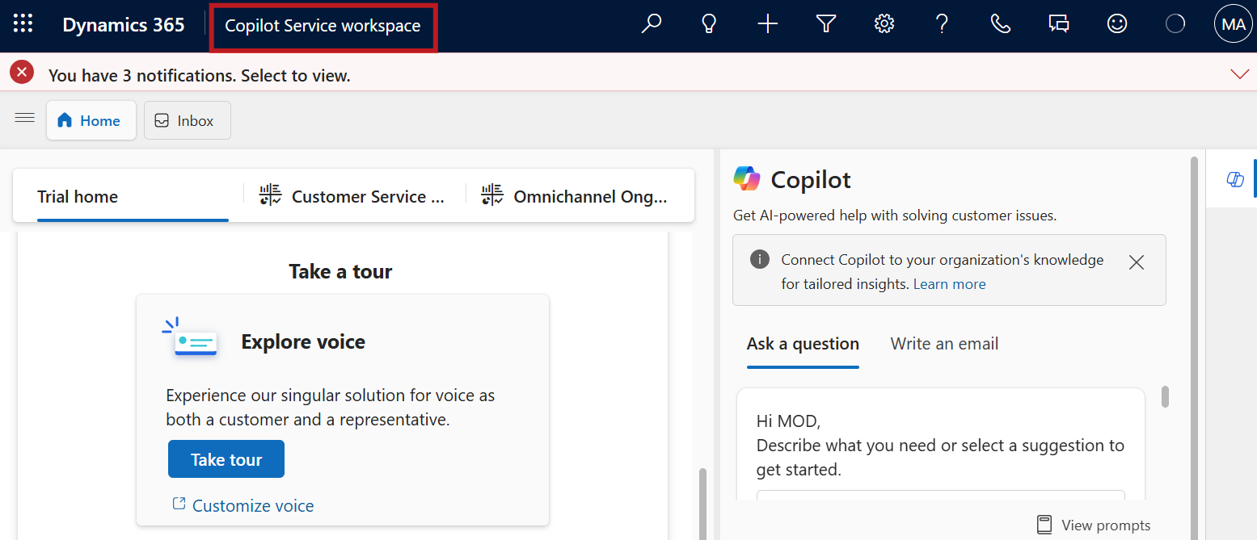

1. Under **Apps**, select **Copilot Service Admin Center**.

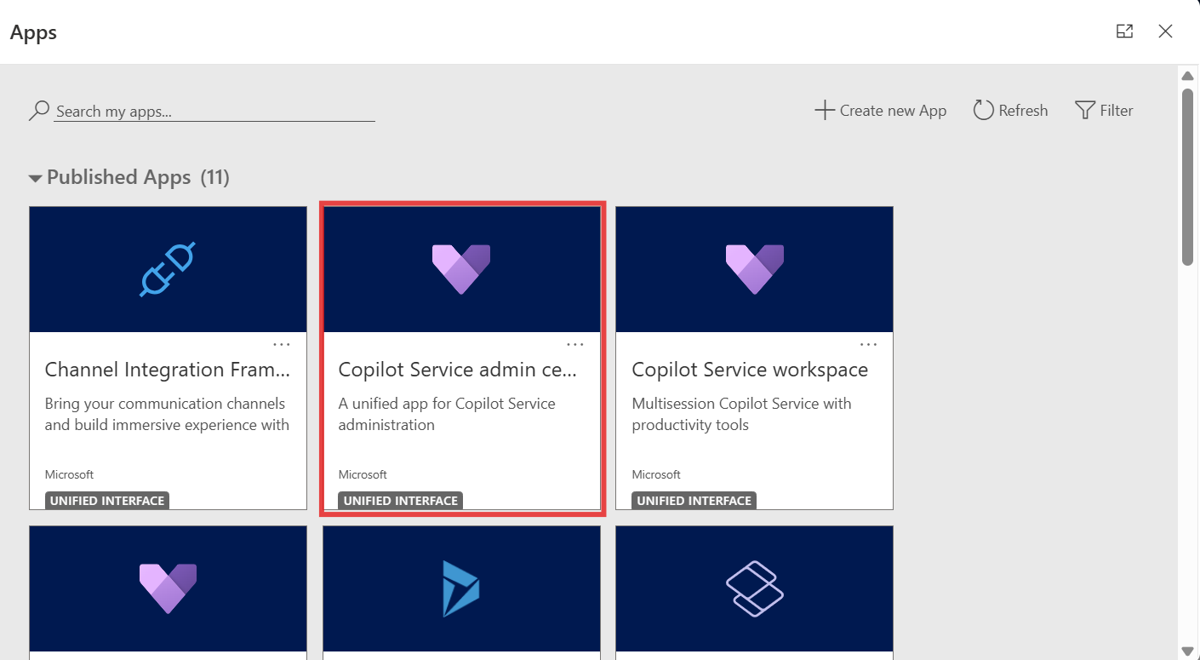

1. Select **Productivity** under **Support experience**.

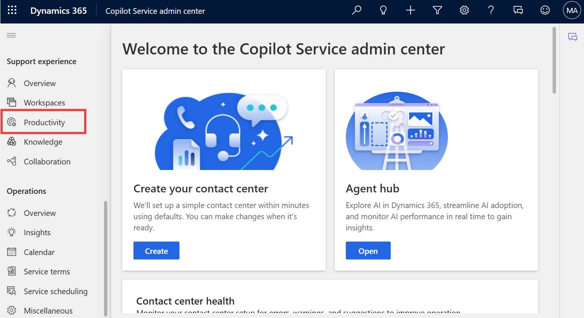

1. In the **Productivity** pane, select **Manage** for **Copilot for questions and emails**.

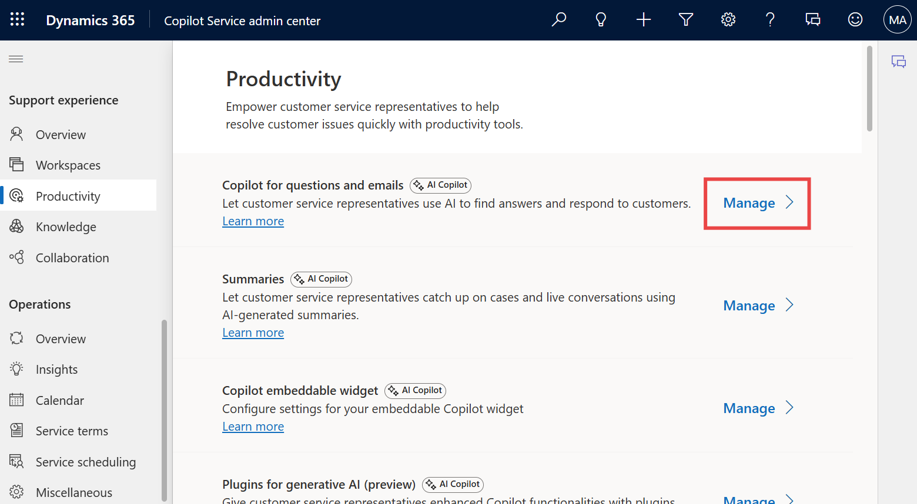

1. Check the following checkboxes

* Ask a question,
* Help pane – write an email
* Email sentiments (preview)
* Copilot recommended email templates
* Include a knowledge base or another type of knowledge source
* Scroll down, check the checkbox for Let representative translate responses under Translation.

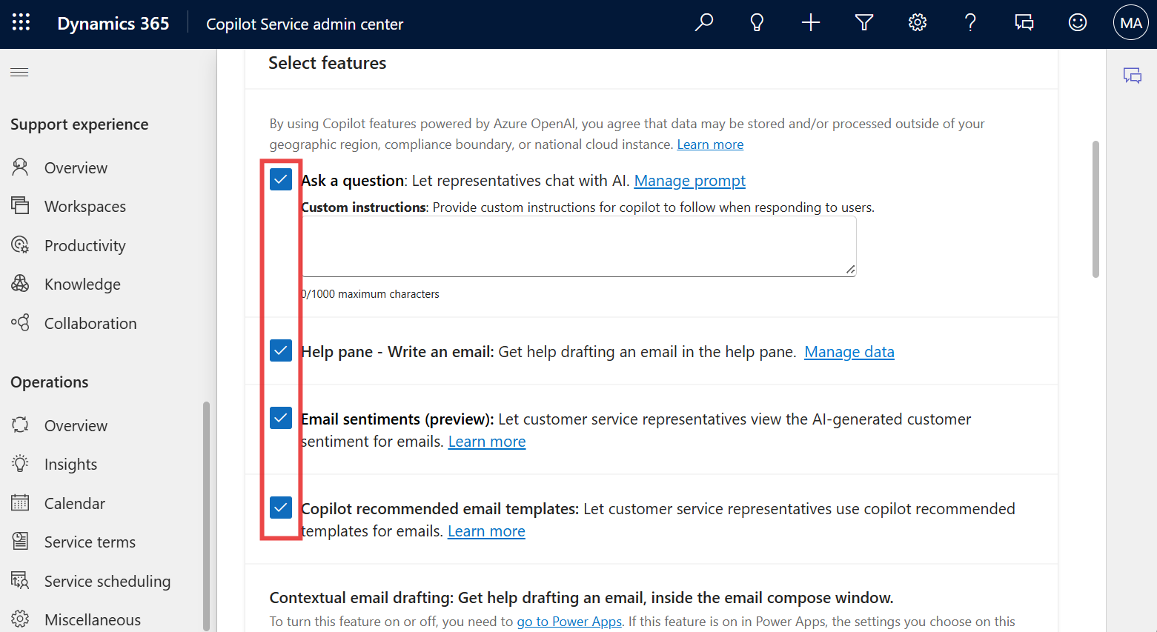

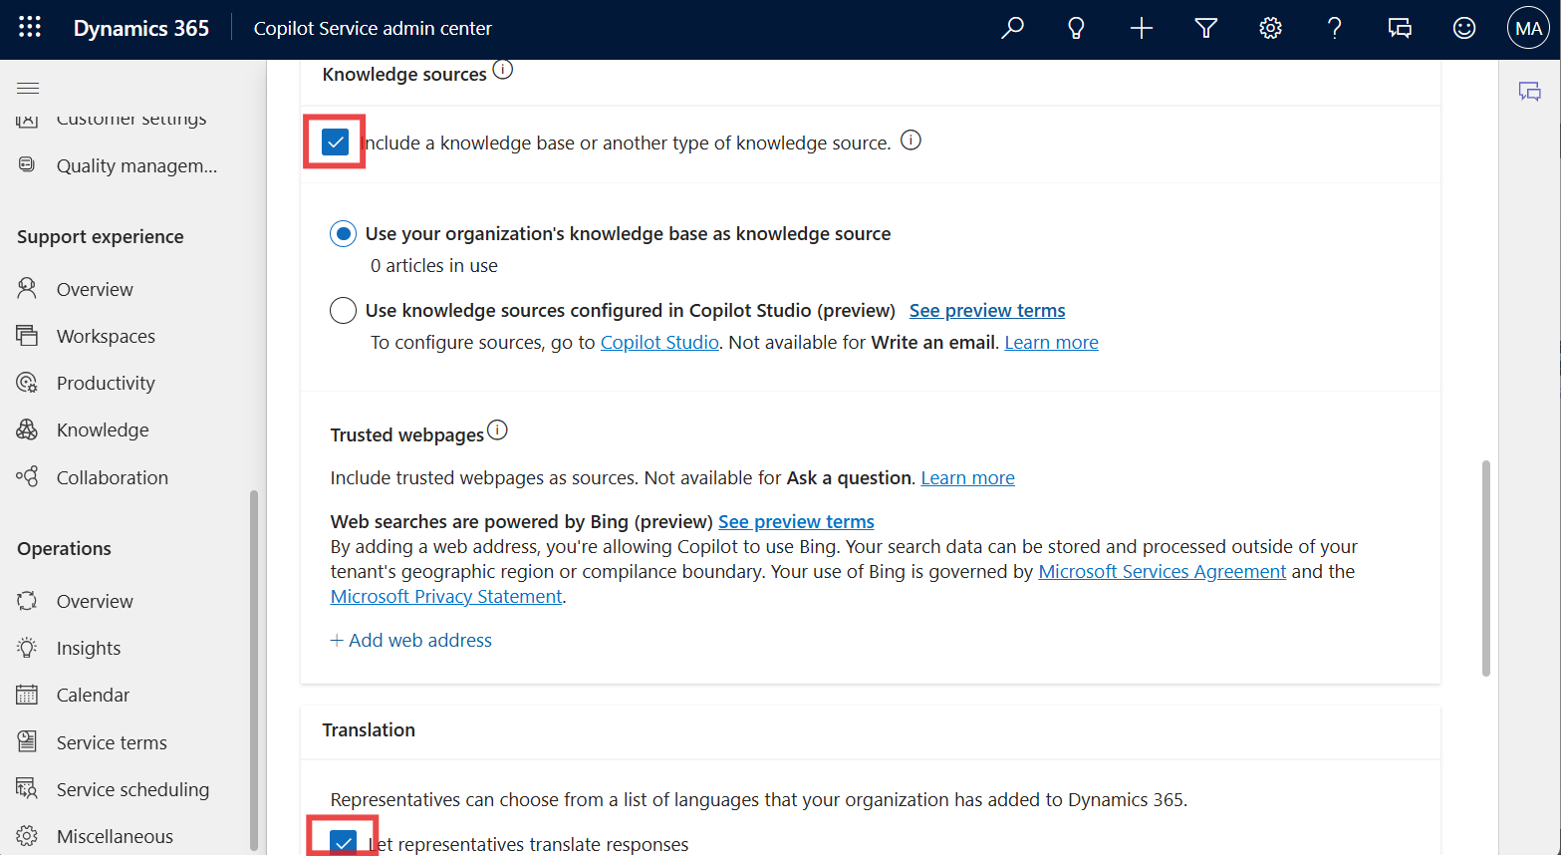

1. Select **Save and close**.

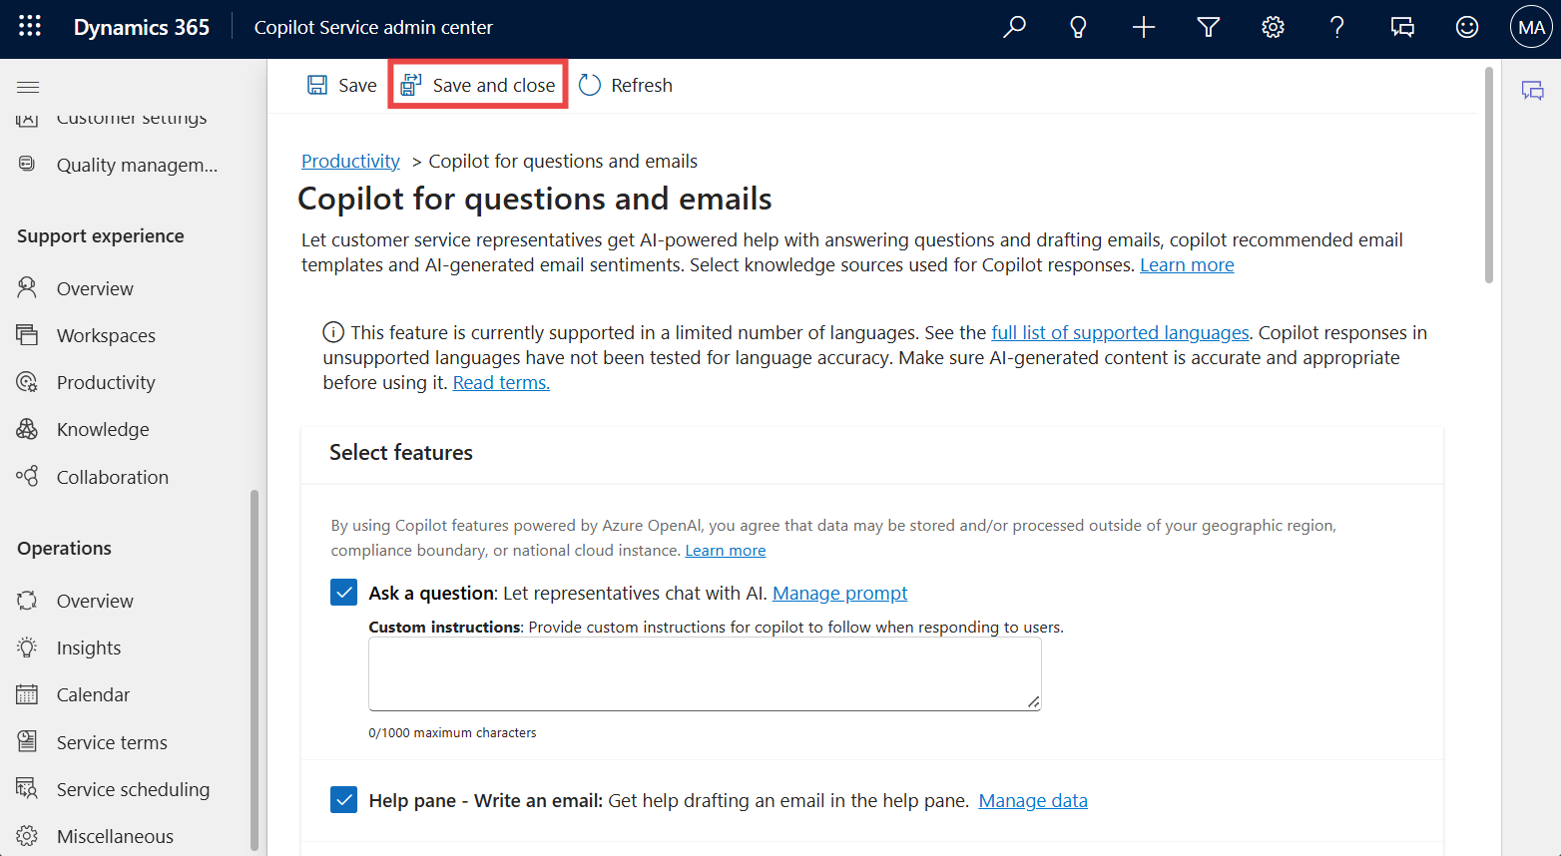

1. Select **Manage** for **Summaries**.

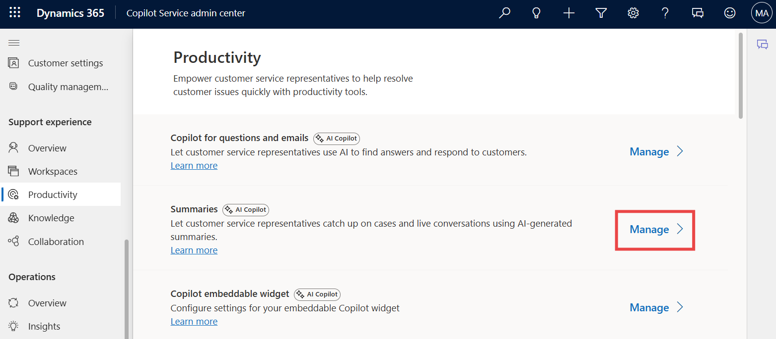

1. Select the **Make case summaries available to agents** check box, select all the check boxes under **Live conversation summaries** and then select **Save and close**.

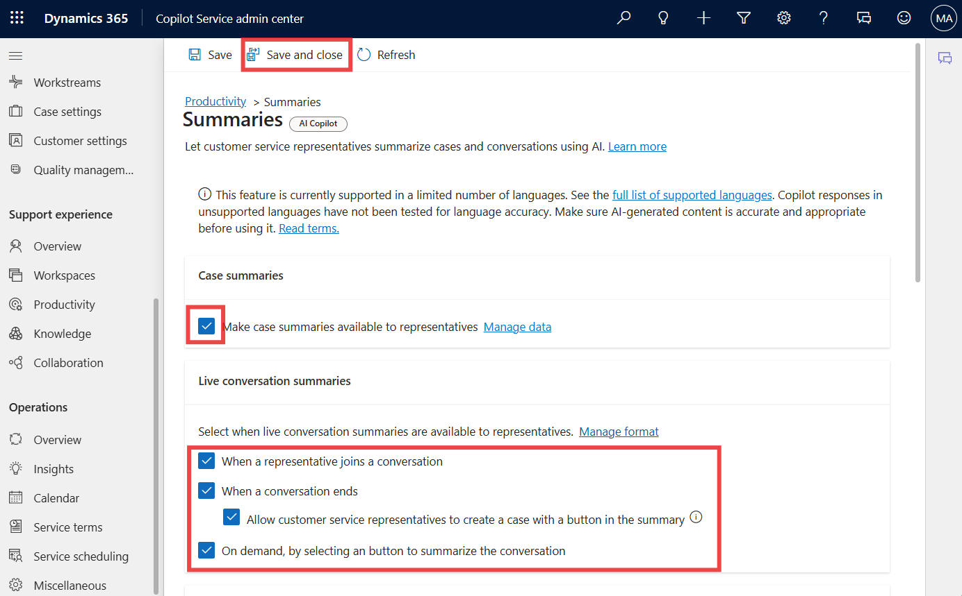

## **Exercise 4: Assign Field Service trial license and install the Field Service Outlook Add-in**

### **Task 1: Assign Field Service trial license**

1. Navigate to the **Field Service product page** using the given link [**https://www.microsoft.com/en-us/dynamics-365/products/field-service**](urn:gd:lg:a:send-vm-keys) and select the **Try for free** button.

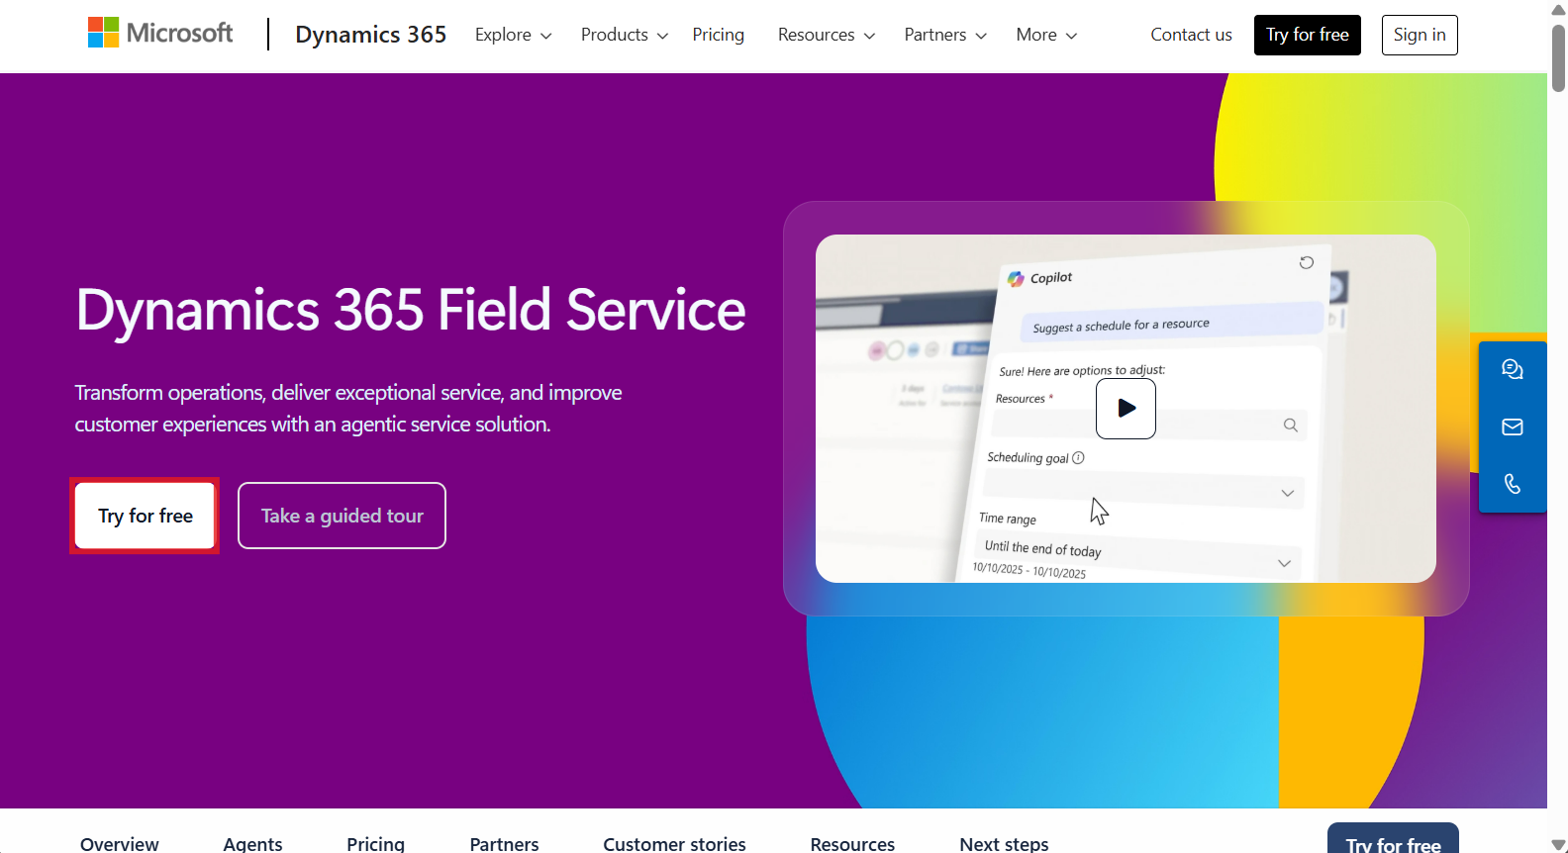

1. Enter your **Office 365 admin tenant username**, select the checkbox for service agreement and then select **Start your free trial**.

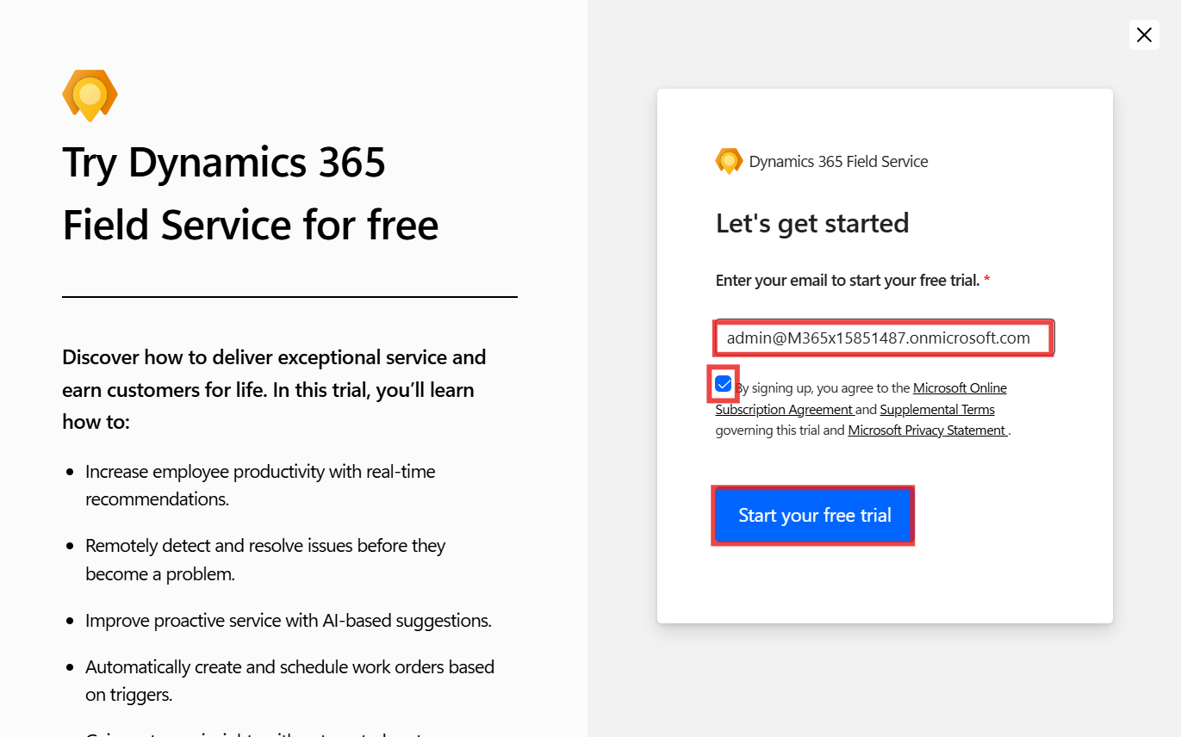

1. Provide **Contact Information** as below and then select **Submit**.
   * **Job title**: Your job title
   * **Country/region**: United States
   * **Phone number**: Your phone number

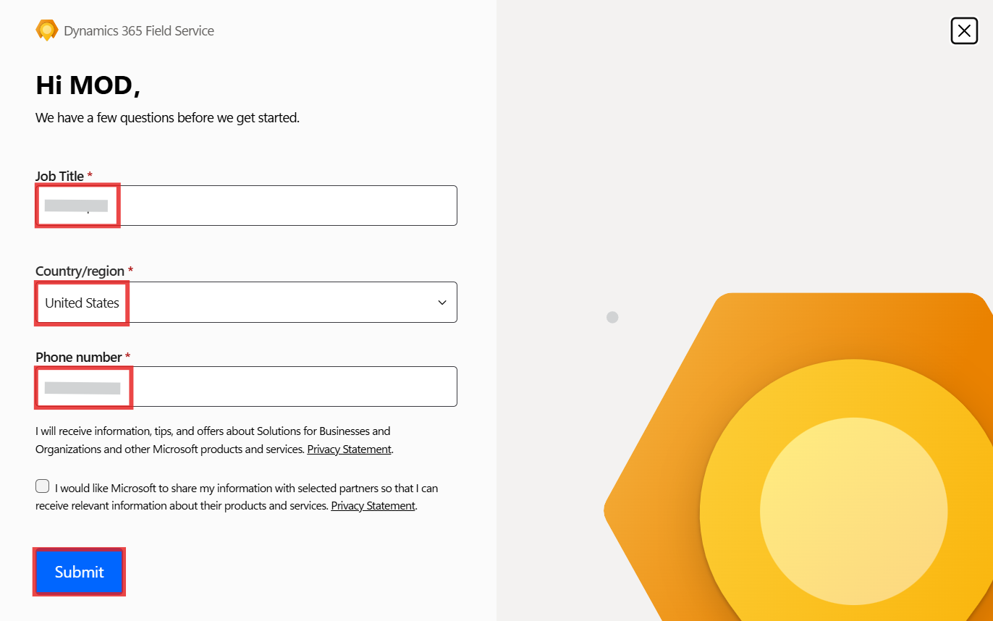

1. If Pop-up regarding **Whats new** appears, **close** it.

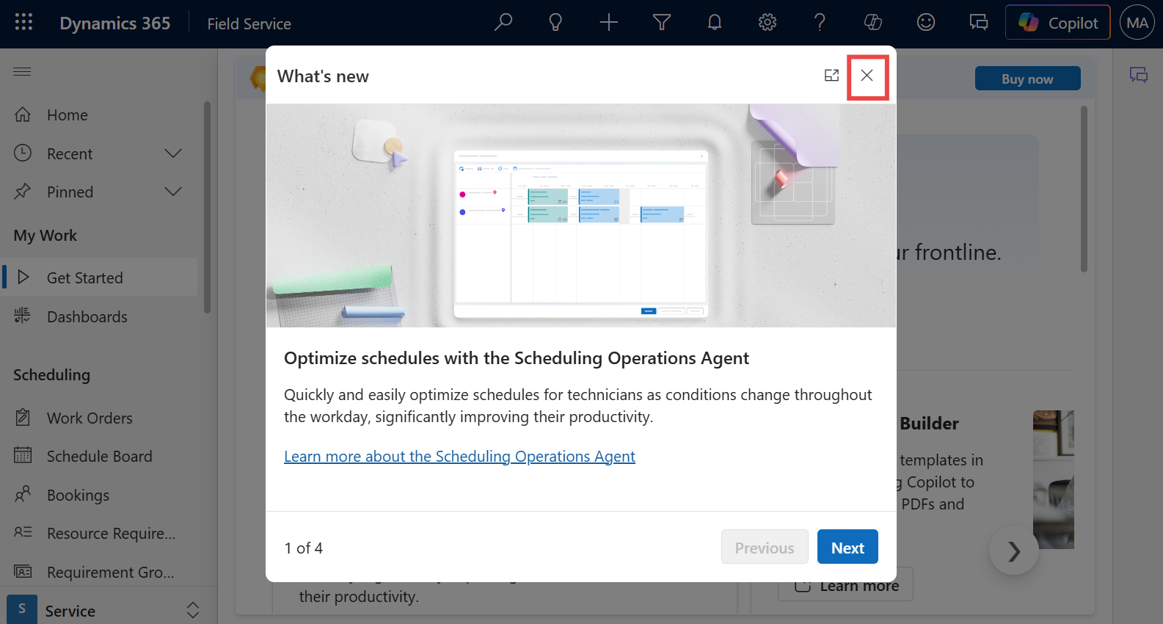

1. You will be navigated to the **Dynamics 365 Field Service portal**.

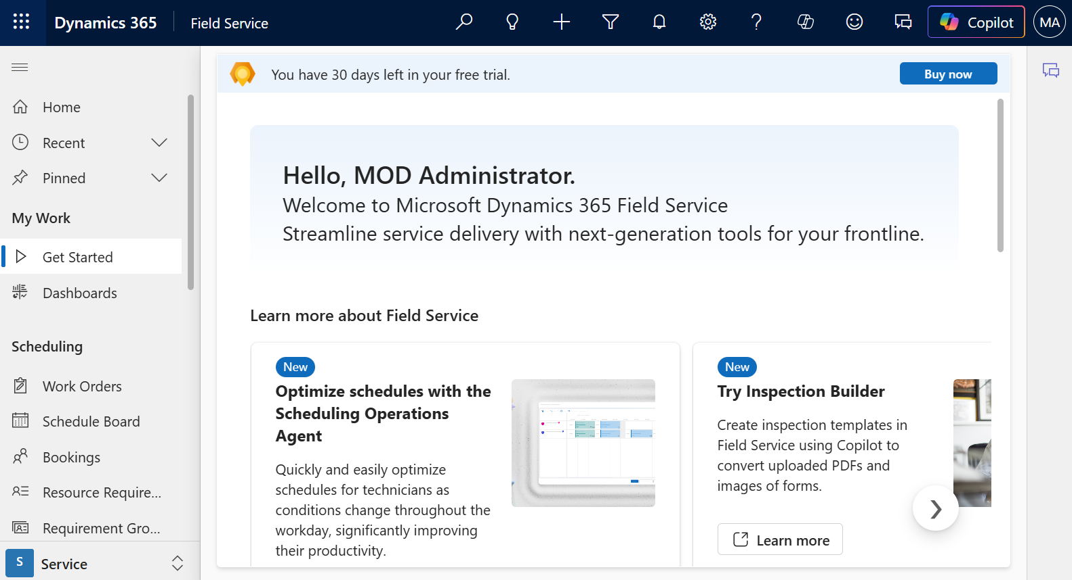

1. Go to **Power Platform admin center** by navigating to [**https://admin.powerplatform.microsoft.com/**](urn:gd:lg:a:send-vm-keys) and if required, sign in using your given **Office 365 tenant admin** credentials. From left navigation pane, click on **Manage** > **Environments** and then you can see, **Field Service Trial environment** is created.

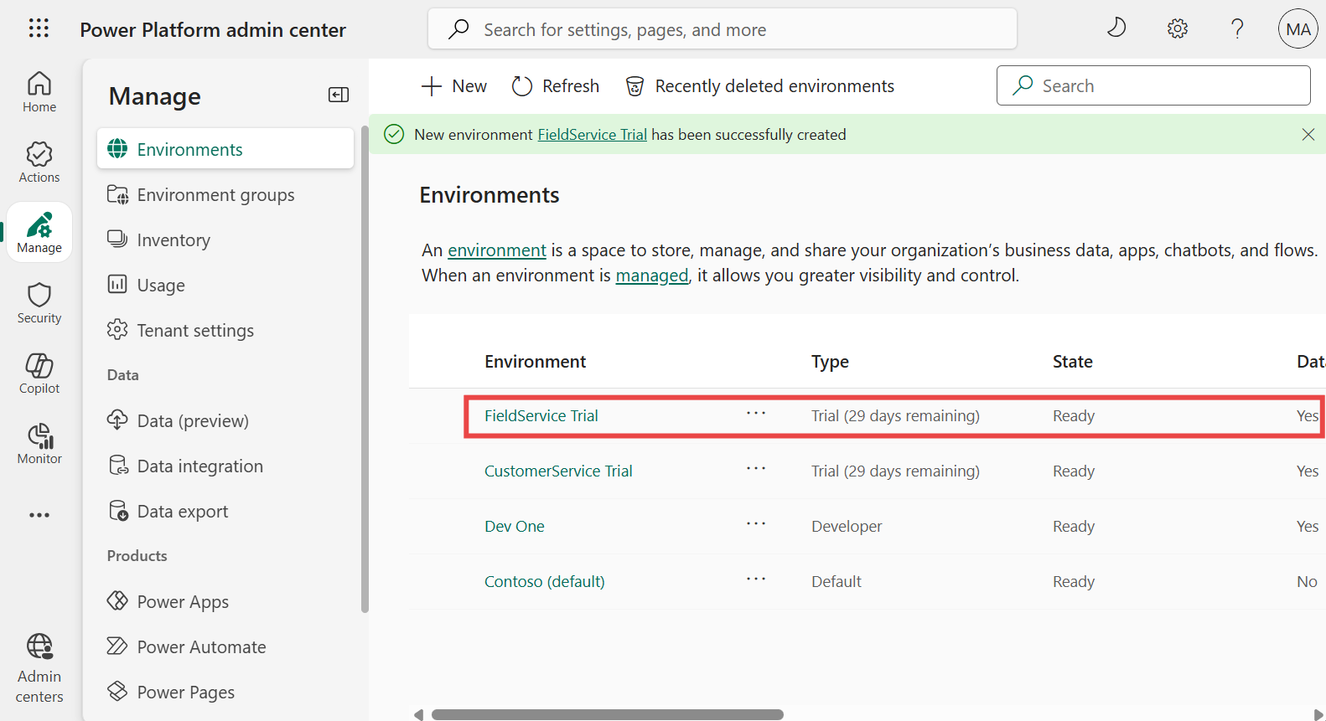

## **Exercise 5: Get Dynamics 365 Sales trial license and install Sales app in Outlook**

### **Task 1: Sign up for a free Dynamics 365 Sales trial**

1. Go to the **Sales overview** page using the given URL [**https://www.microsoft.com/en-us/dynamics-365/products/sales**](urn:gd:lg:a:send-vm-keys) and select **Try for free**.

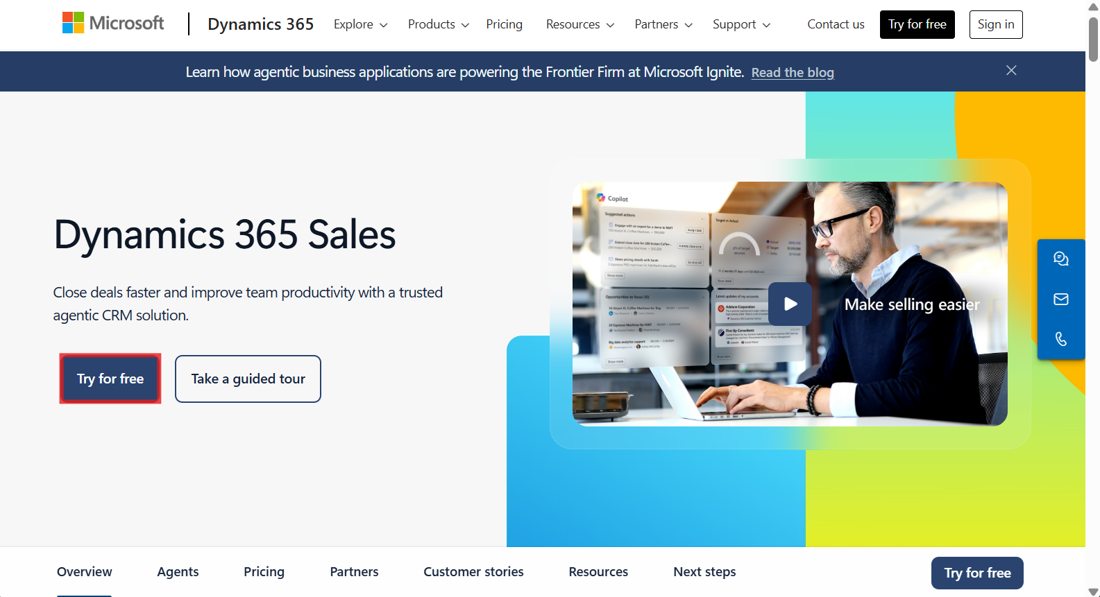

1. Enter your **Office 365 admin tenant** credentials, select the checkbox to **accept the agreement** and click on **Start your free trial**.

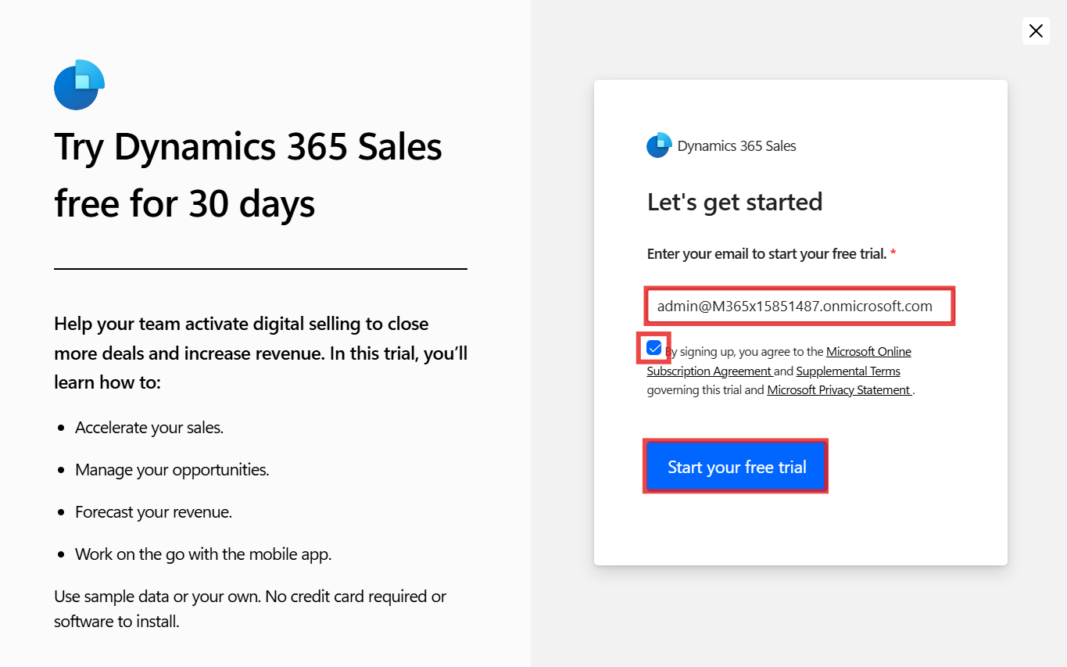

1. Provide **Contact Information** as below and then select Submit.

* **Job title**: Your job title
* **Country/region**: United States
* **Phone number**: Your phone number

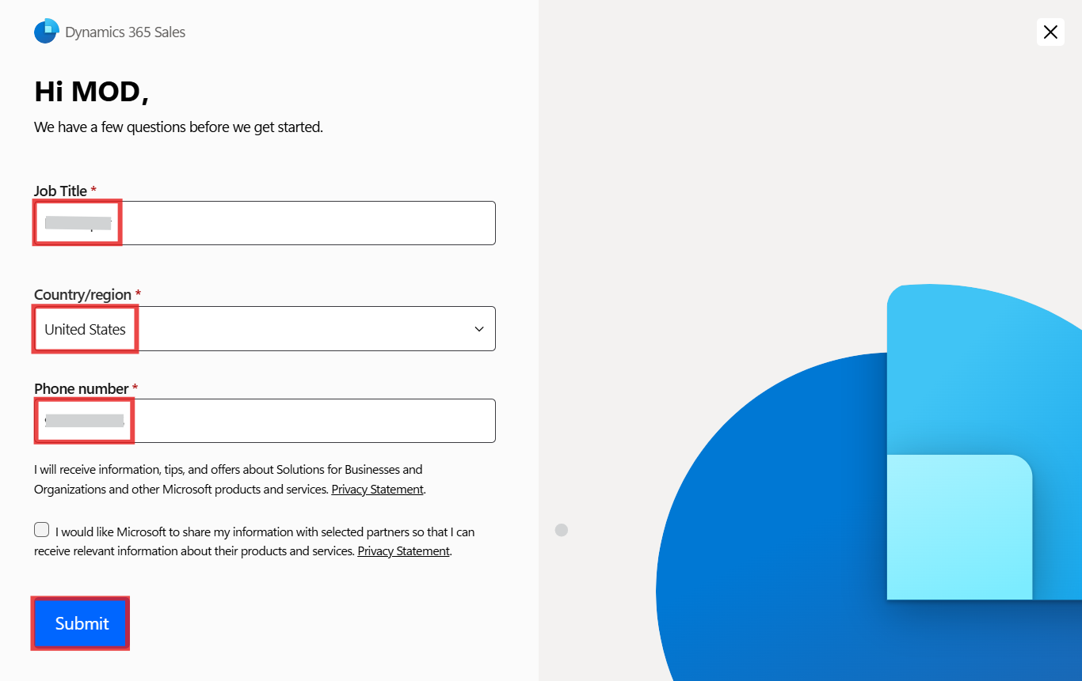

1. If asked, enter your **Office 365 admin tenant** password.

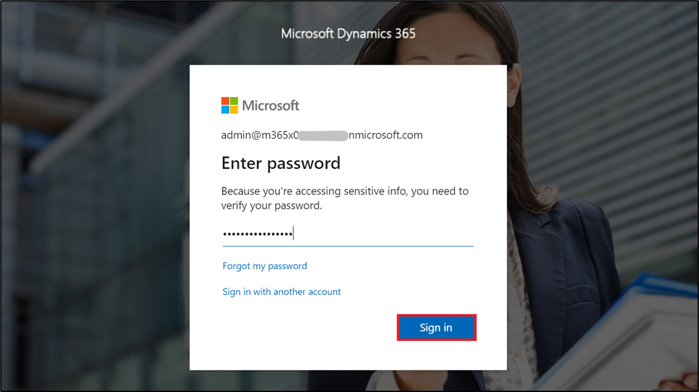

1. You will be landed to the **Dynamics 365 Sales** portal.

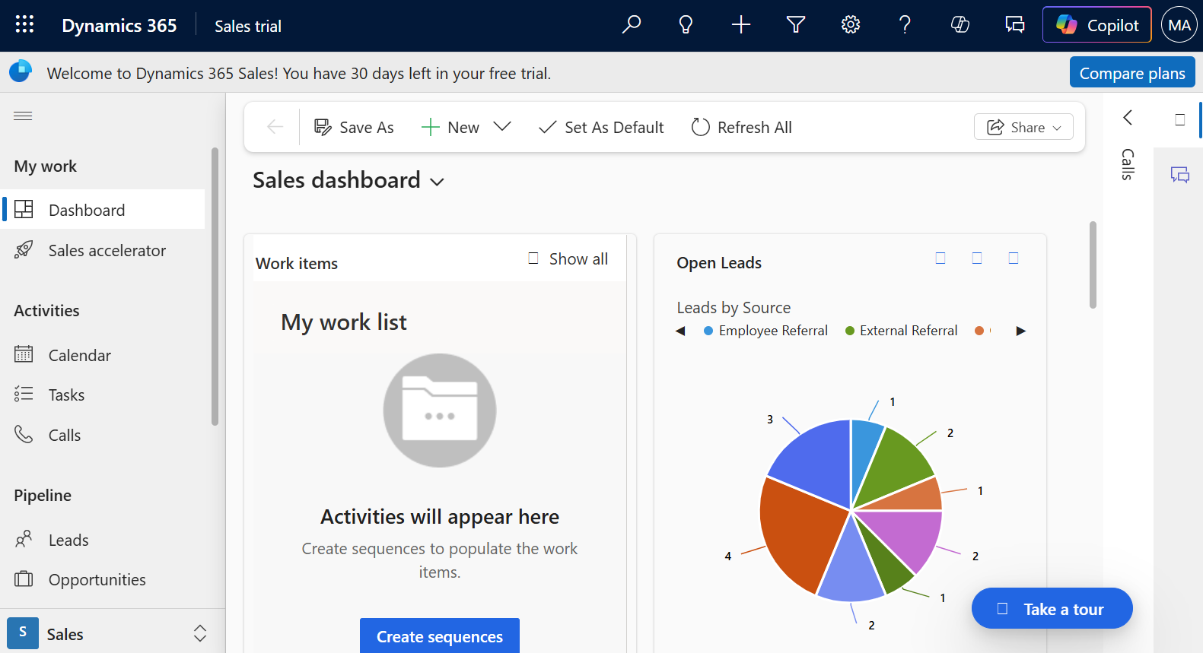

1. Go to **Power Platform admin center** by navigating to [**https://admin.powerplatform.microsoft.com**](urn:gd:lg:a:send-vm-keys) and if required, sign in using your given Office 365 tenant admin credentials. From left navigation pane, click on **Manage** > **Environments** and then you can see, **Sales Trial environment** is created.

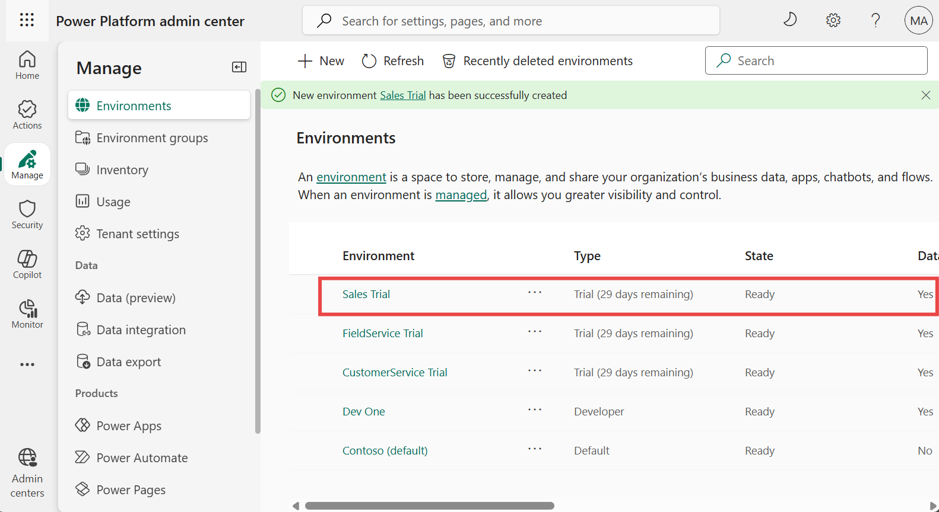

### **Task 2: Install Sales app in Outlook**

1. Sign in to the **Microsoft 365 admin center** with the given link [**https://admin.microsoft.com/**](urn:gd:lg:a:send-vm-keys).
2. In the You need to set up multifactor authentication pop-up window, select **Set up now**.

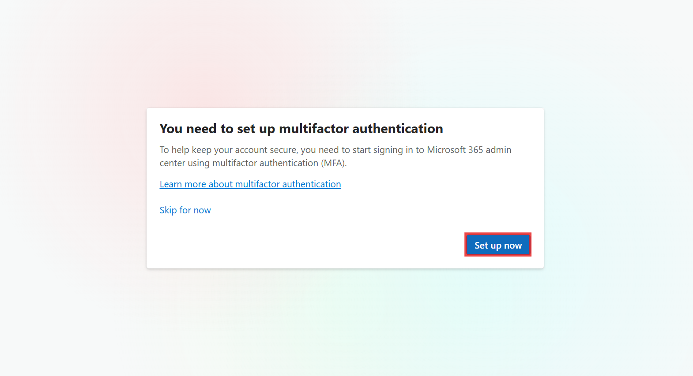

1. Select **Next** on the **Let’s keep your account secure** screen.

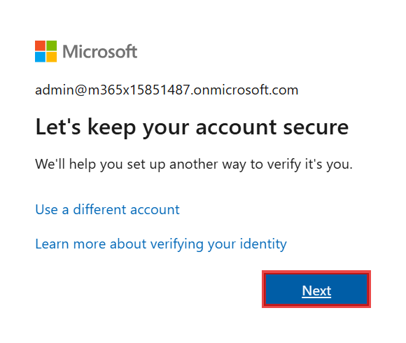

1. Select **Next** on the **Install Microsoft Authenticator** screen.

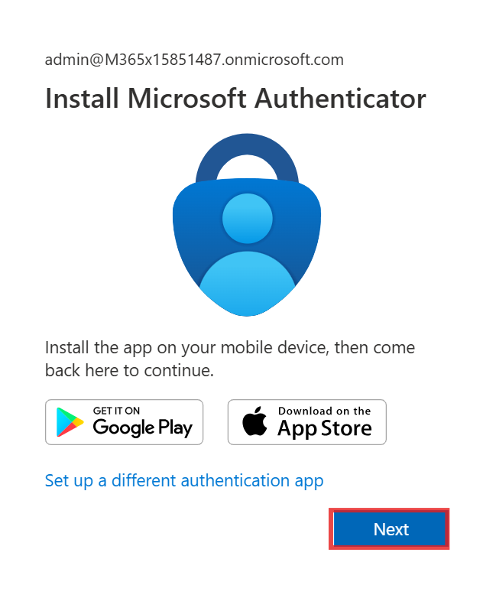

1. Select **Next** on the **Set up your account in app** screen.

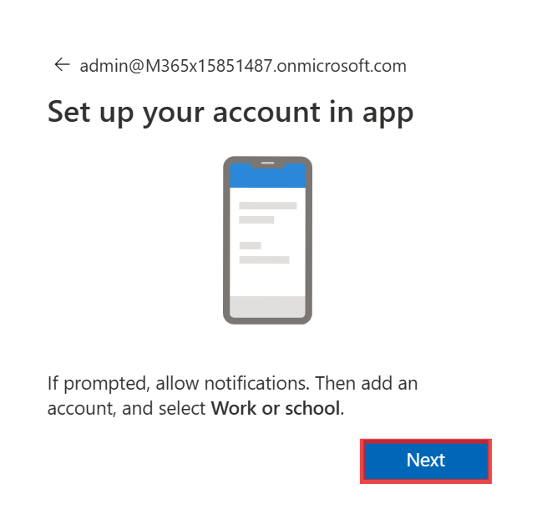

1. Scan the QR code from the Authenticator app on your mobile phone and then select **Next**.

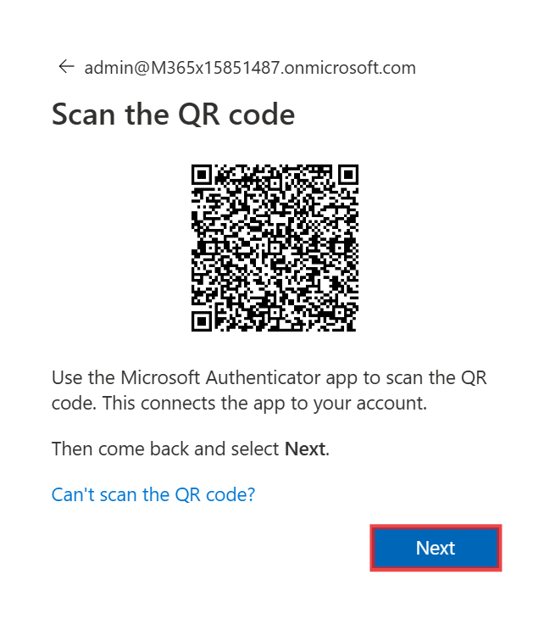

1. Enter the number displayed on your screen into the app on your mobile phone.

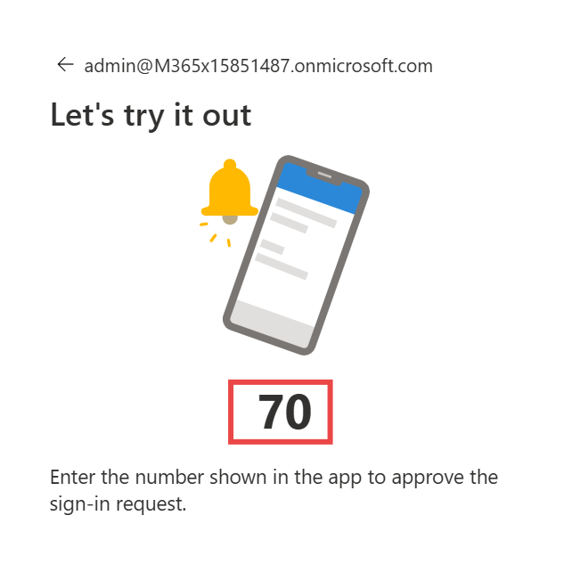

1. Once the number is entered, you will see the **Authenticator added** screen. Select **Done**.

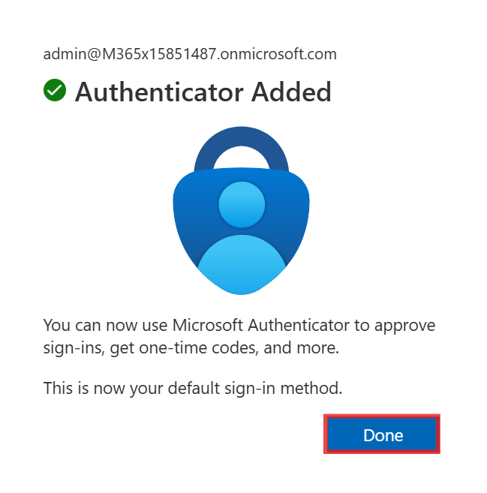

1. On the Microsoft 365 admin center portal, from the left side pane, select **Show all**.

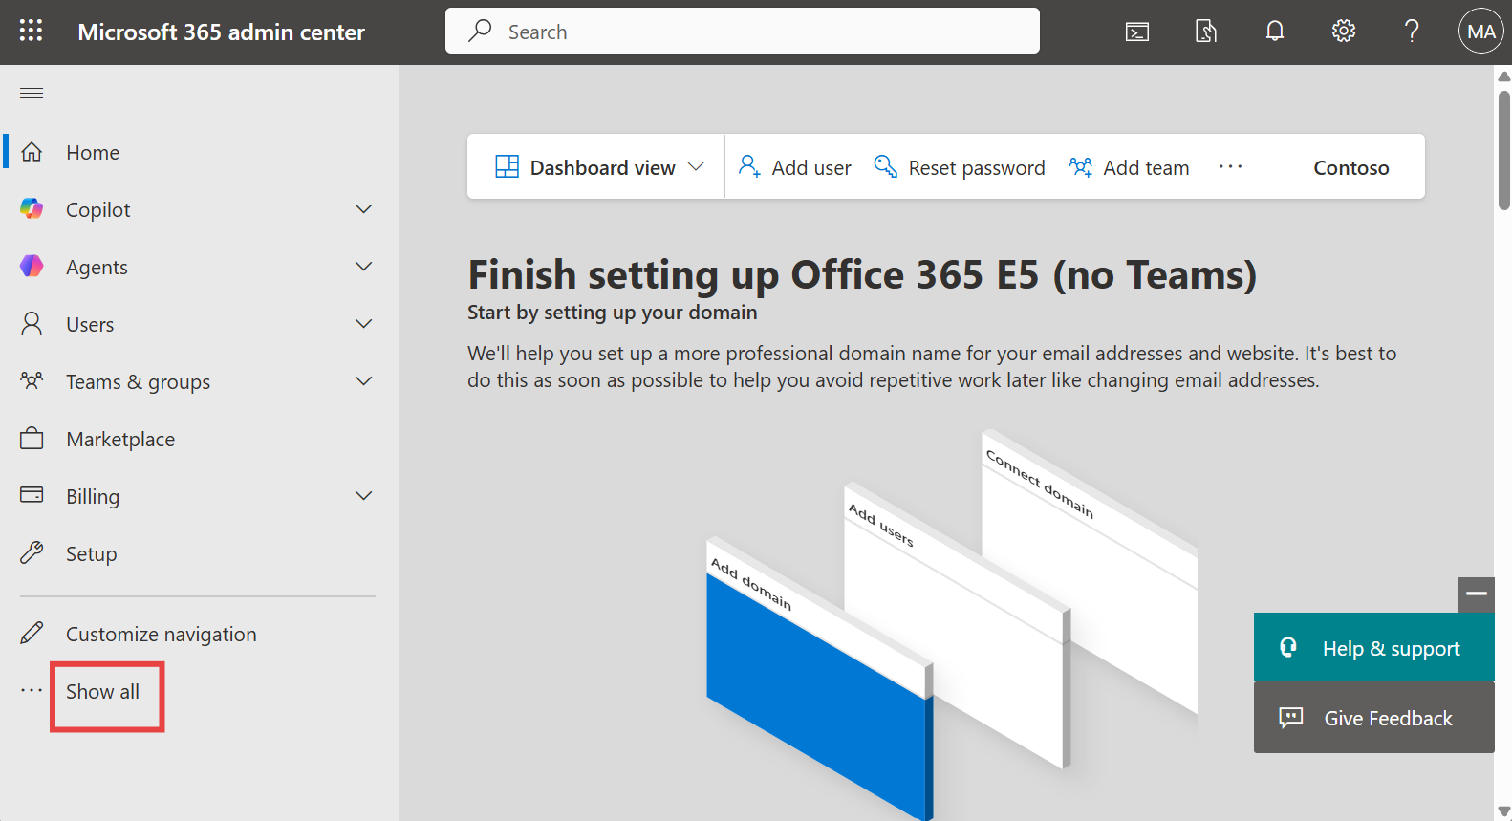

1. In the left pane, select **Settings > Integrated apps**.

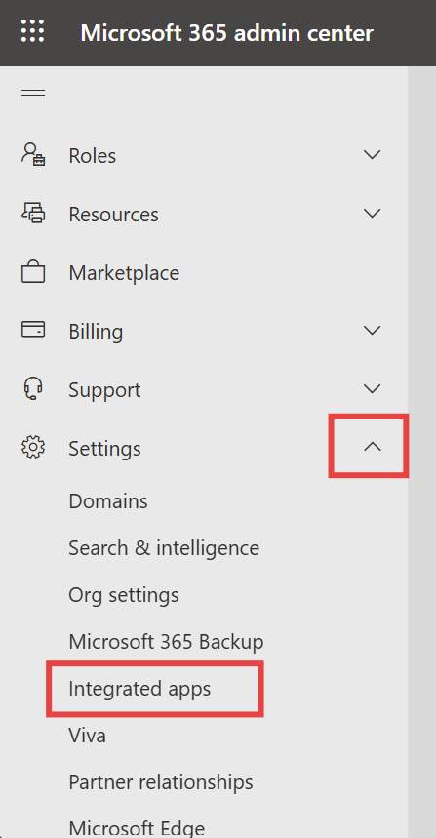

1. On the **Integrated apps** page, select **Get apps**. **Microsoft AppSource** opens in an embedded window.

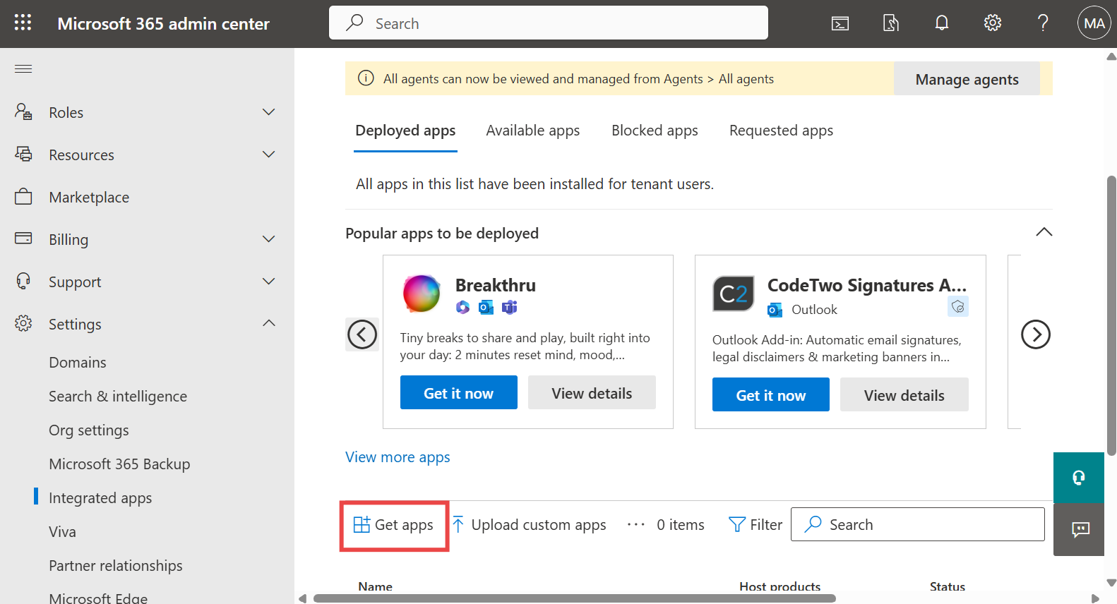

1. In the **AppSource** window, search for **Sales**.

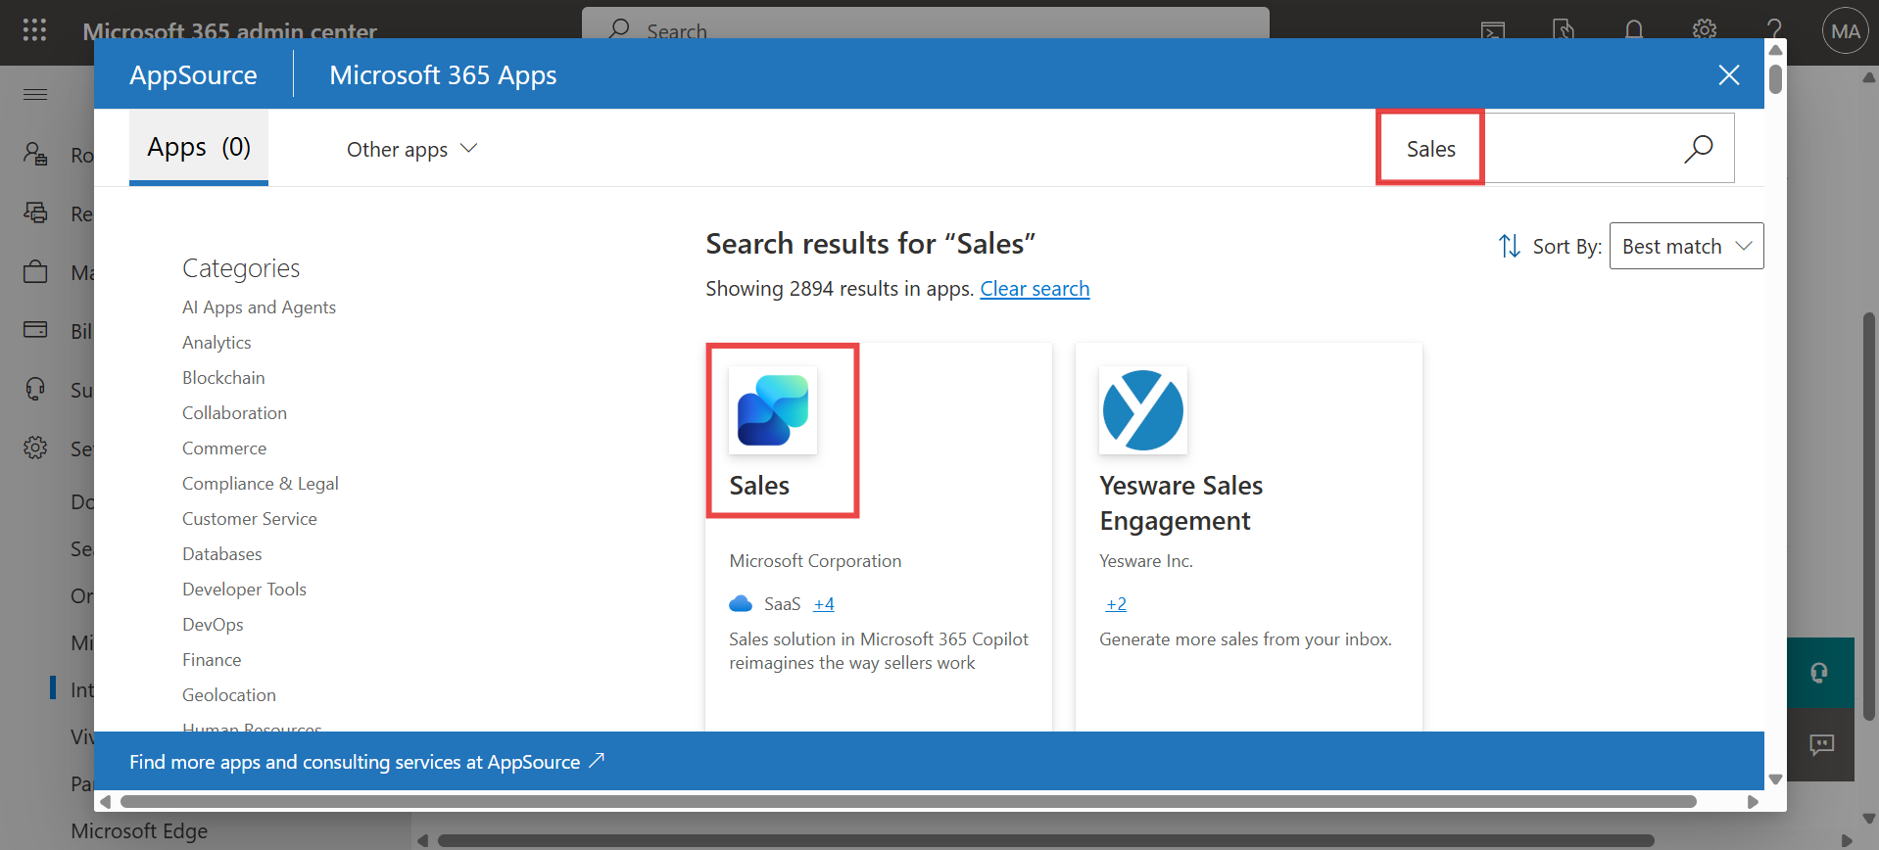

1. In the search results, select **Sales**, and then select **Get it now**.

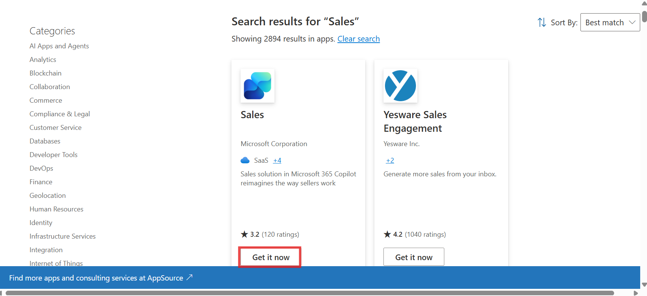

1. On **the Confirm to continue** page, select **Get it now**.

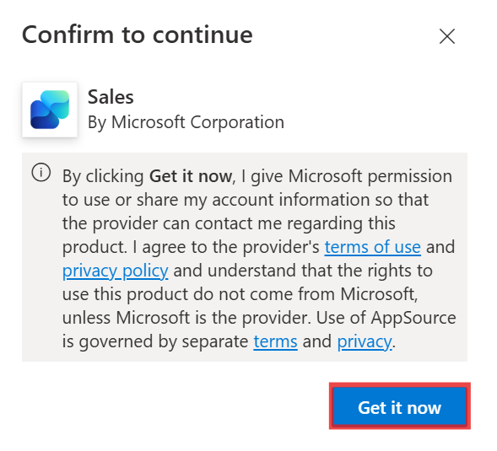

1. In the **Configuration** step, select **Next** on **Apps to deploy** window.

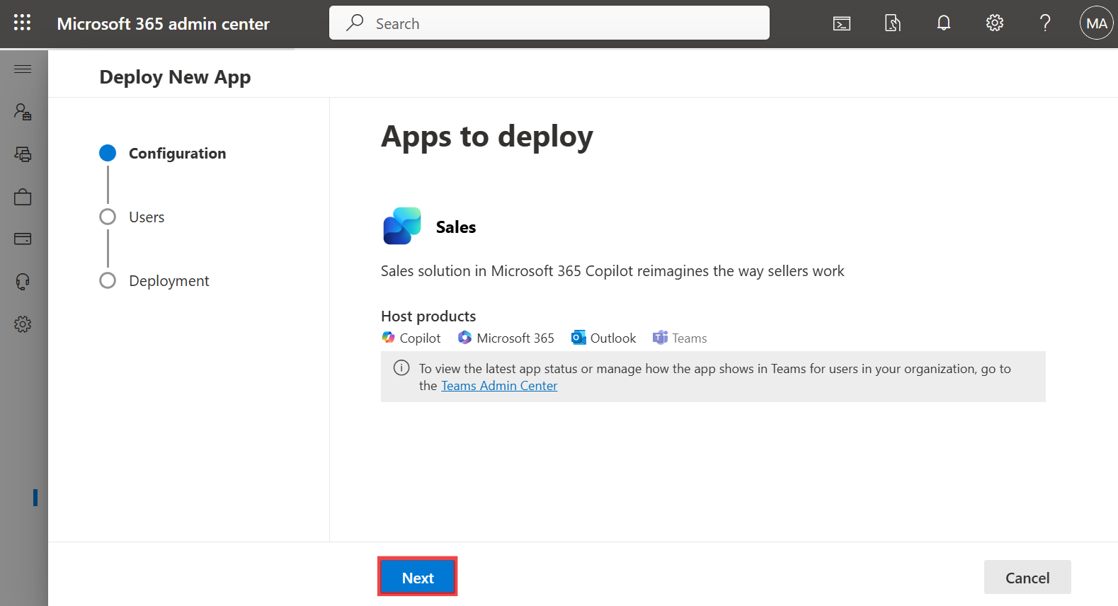

1. In the **Add Users** step, select **Entire organization** under **Assign users**, and then select **Next**.

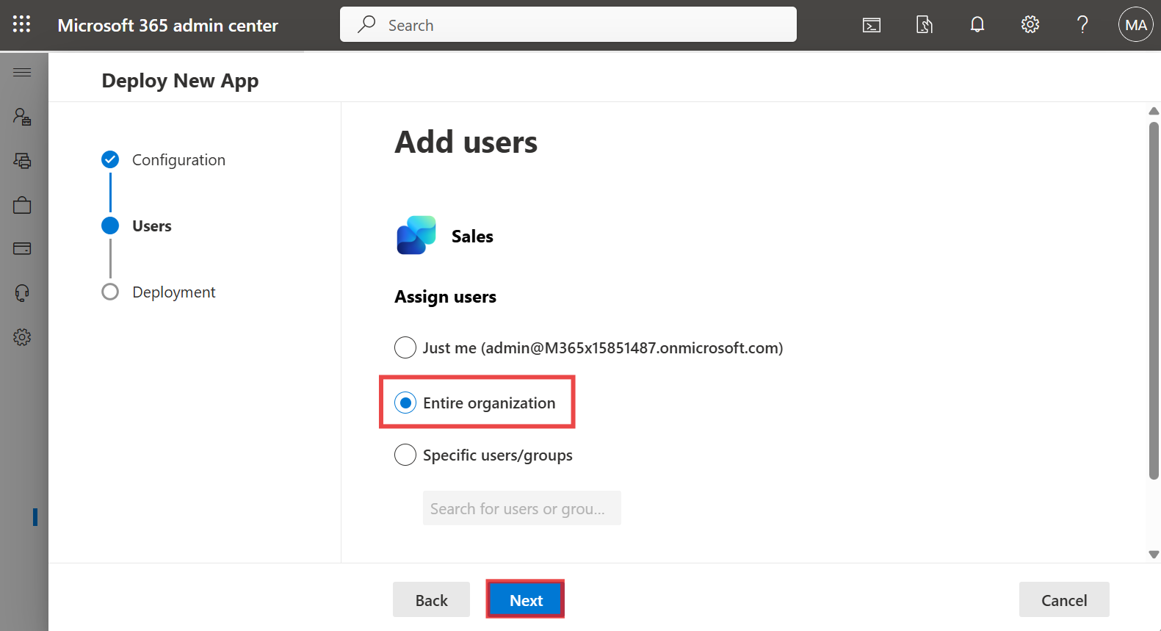

1. In the **Deployment (Permissions)** step, read the app permissions and capabilities for the app to be deployed, select **Accept permissions** for **Copilot for Sales**.

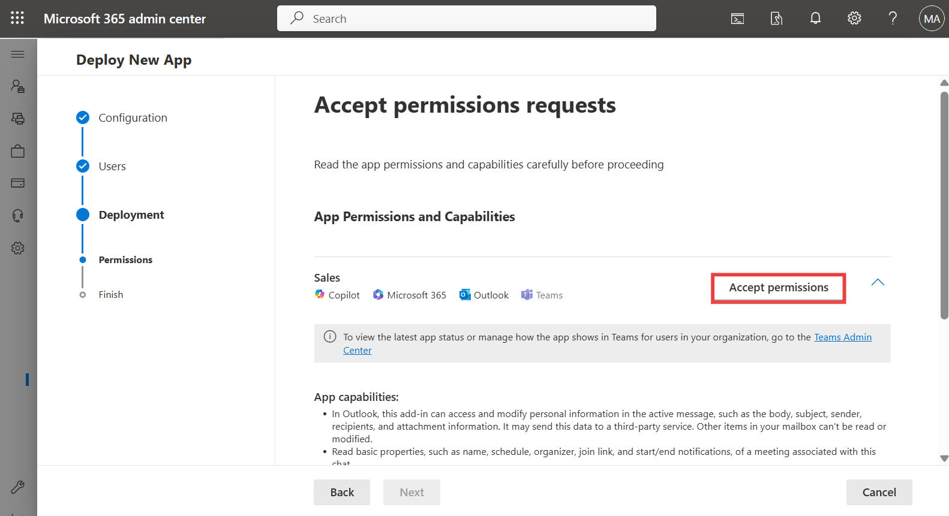

1. Sign in with your **Office 365 admin tenant** credentials on the pop-up window.

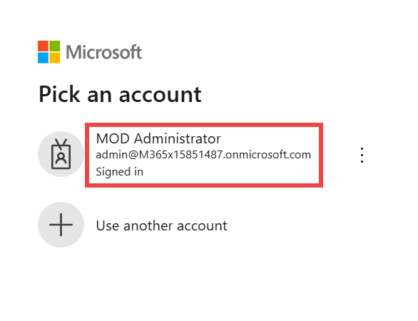

1. Select **Next** on the **Accept permission requests** page.

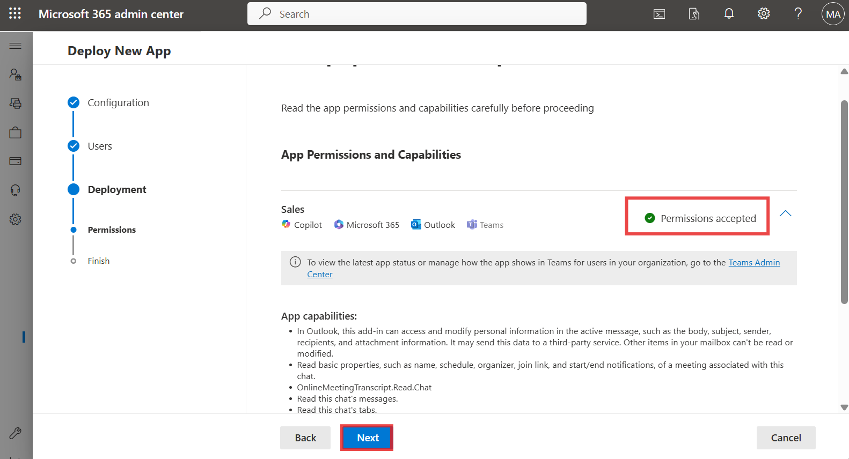

1. In the **Deployment (Finish)** step, review the selected settings, and then select **Finish deployment**.

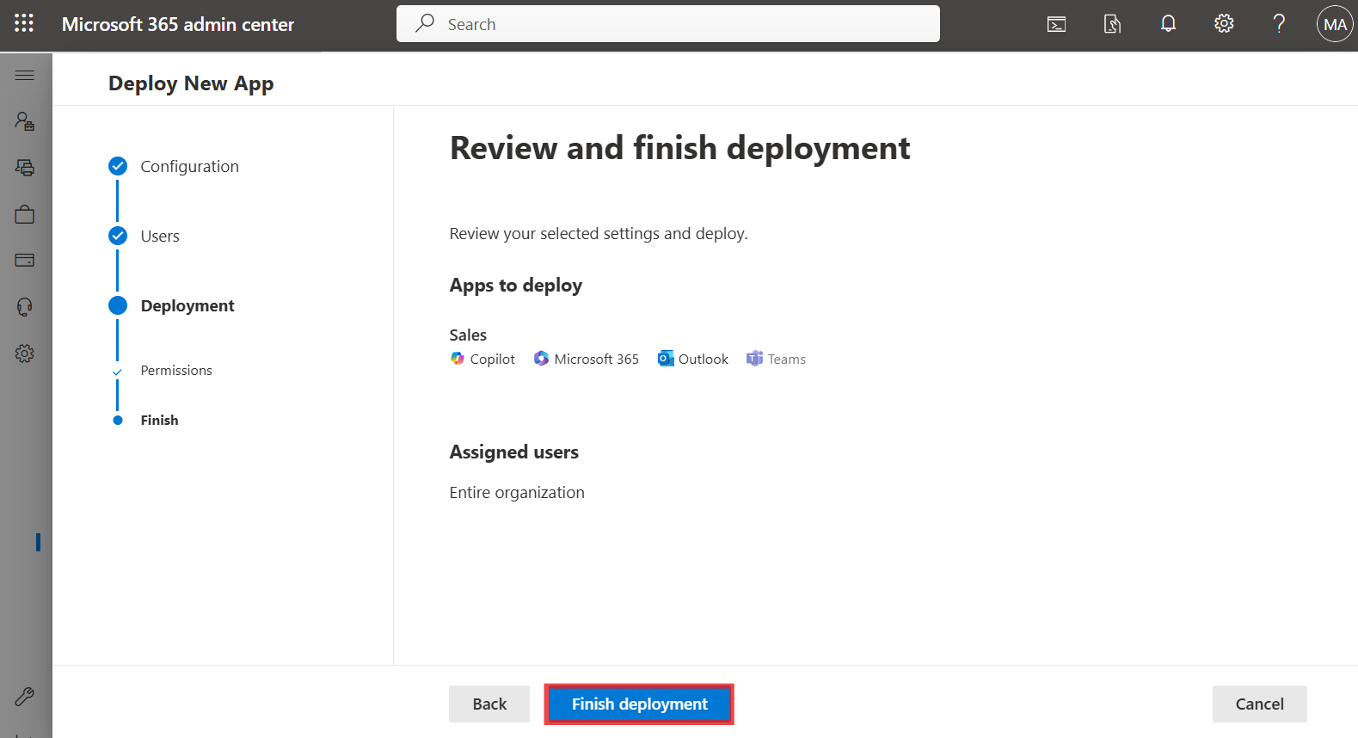

1. When the deployment is complete, select **Done**.

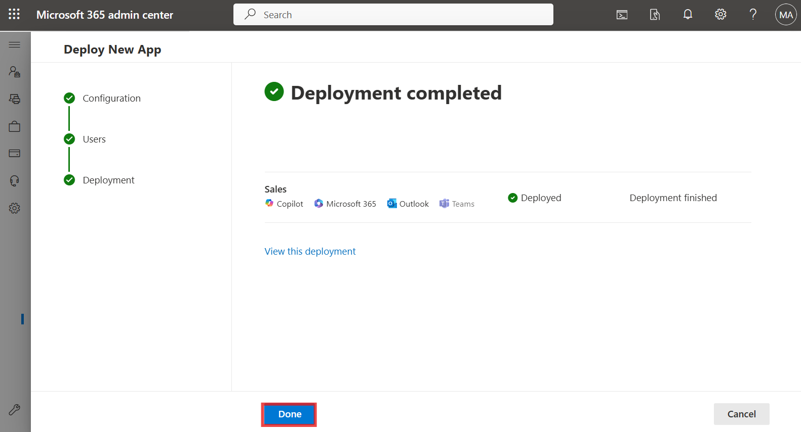

## **Exercise 6: Sign up for the trial and give consent to use Copilot in Customer Insights - Data**

### **Task 1: Sign up for the trial**

1. Go to [**https://dynamics.microsoft.com/en-us/ai/customer-insights/**](urn:gd:lg:a:send-vm-keys)  and choose the **Try for free** button.

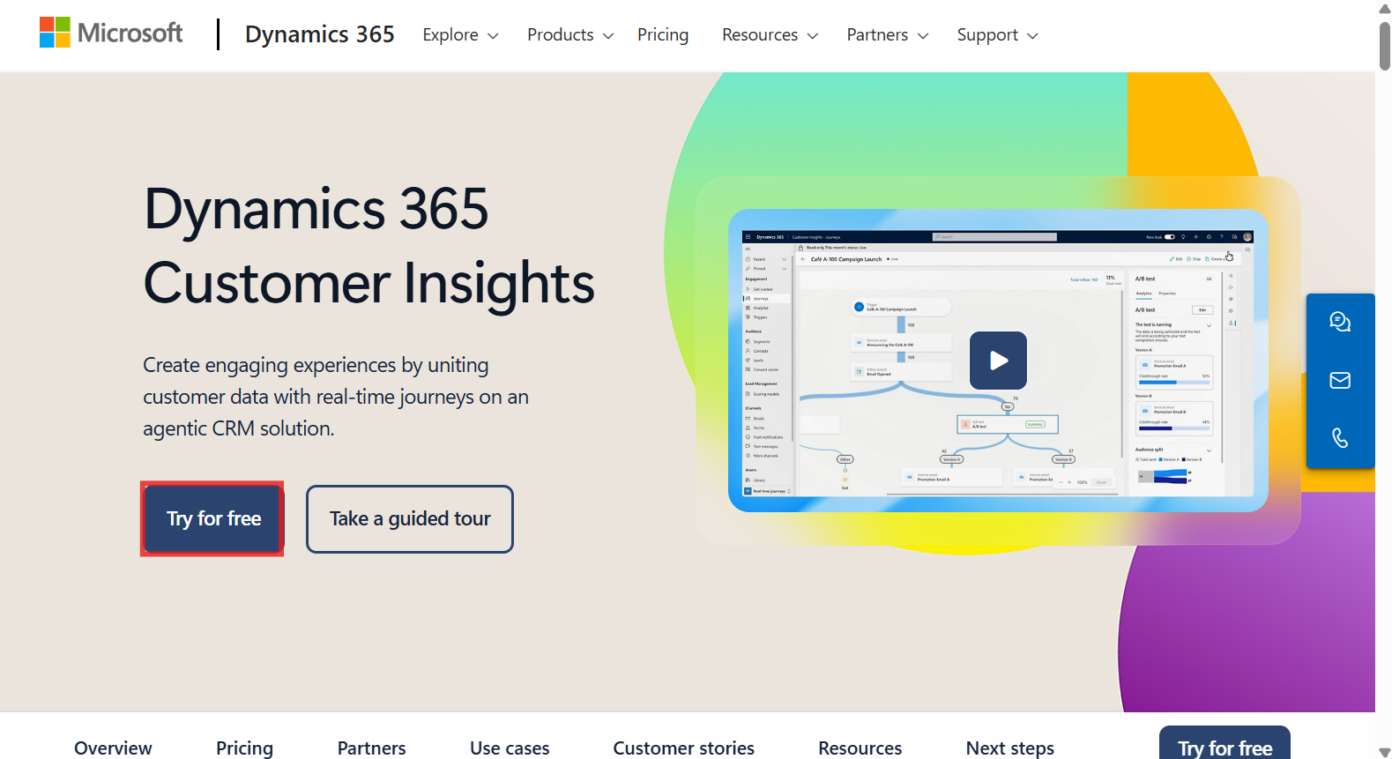

1. Enter your **Office 365 admin credentials**, check the checkbox to **accept the agreement** and click on **Start your free trial**.

[**admin@M365xXXXXXX.onmicrosoft.com**](urn:gd:lg:a:send-vm-keys)

[**MyAdminPassword**](urn:gd:lg:a:send-vm-keys)

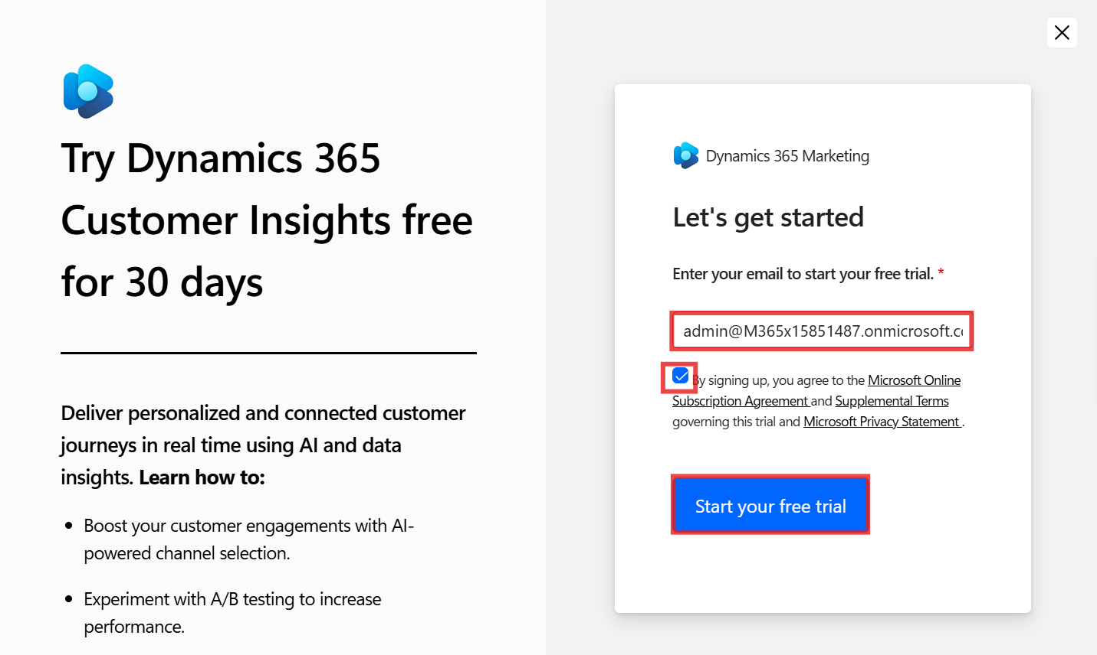

1. Select **United State**s for the **Country/region** field, enter your **phone number** and then select **Submit**.

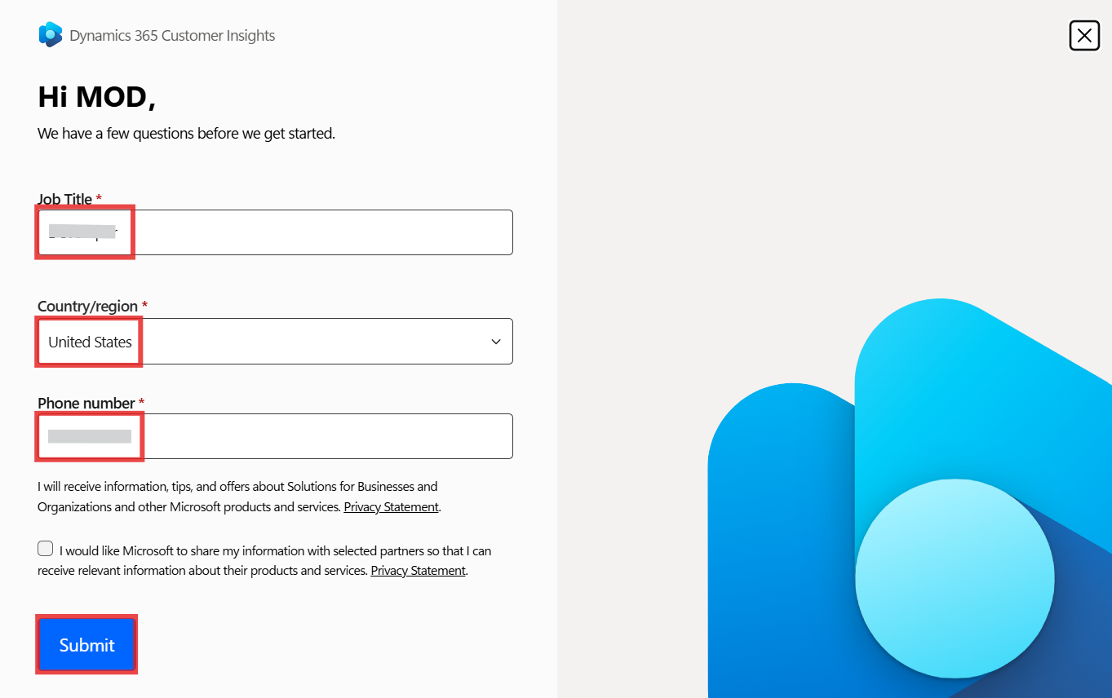

1. Choose **Start Customer Insights - Data.**

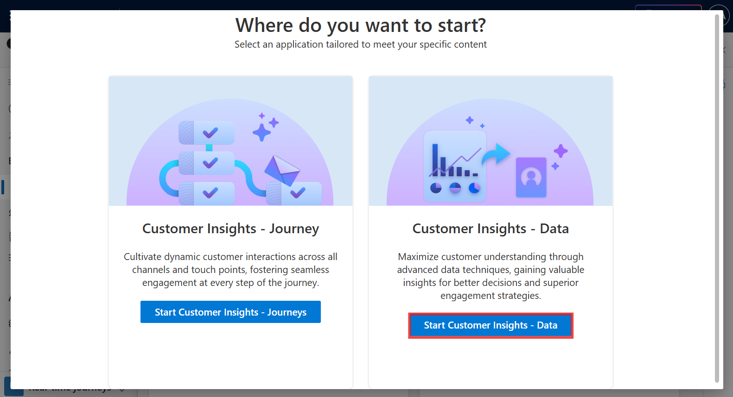

1. Select **United States** for the **Country/region** field and then select **Continue**.

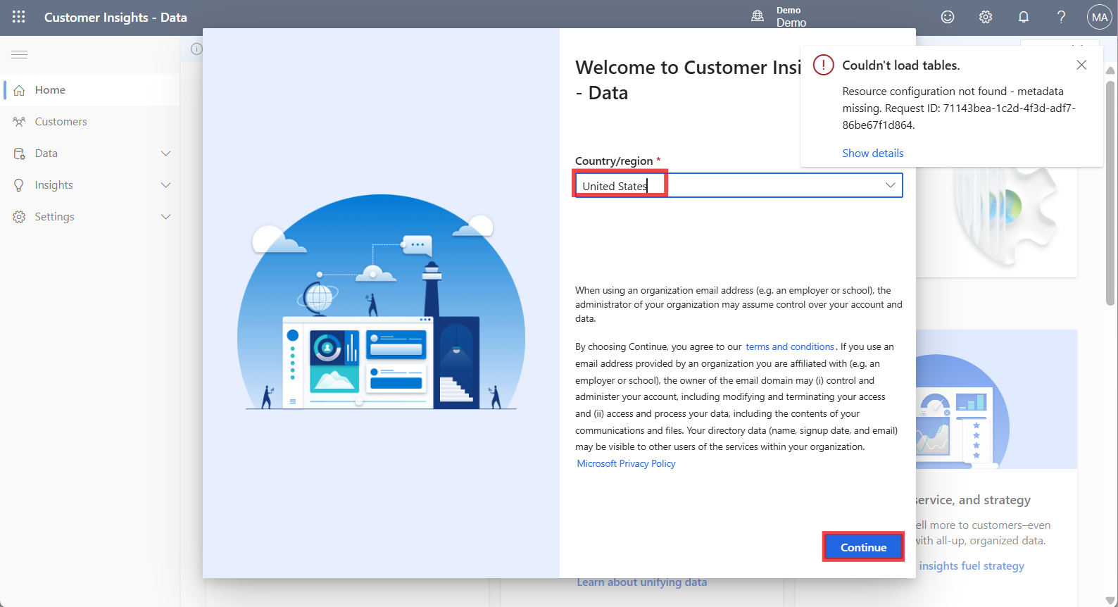

1. Close the **Couldn’t load tables** notification from the right corner of the screen.

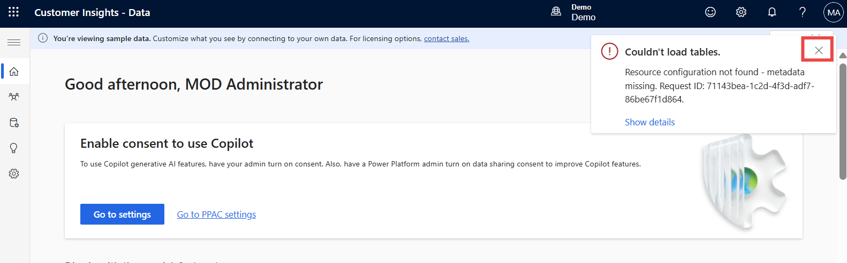

1. Select **Start trial** from the top right corner. If you get an error message as ‘**Couldn’t create environment**’, then follow the steps (a to f) given below and then continue with Step 9.

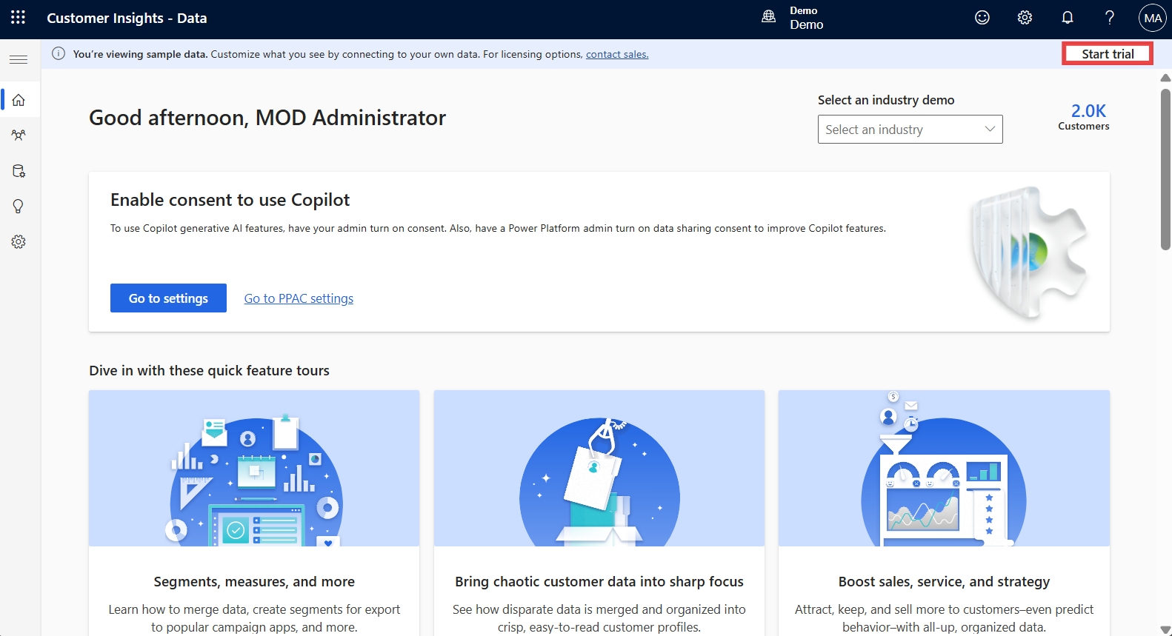

a. Access your **Customer Insights - Data** environment using the given link [**https://home.ci.ai.dynamics.com/**](urn:gd:lg:a:send-vm-keys). Select **Sign up for trial**.

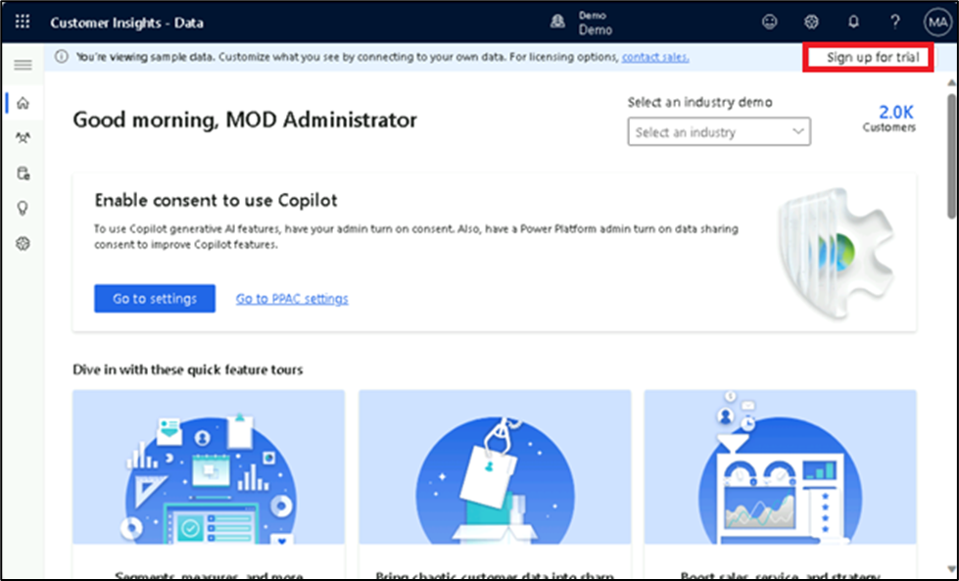

b. **Sign up** using the given **Office 365 tenant** credentials and select **Next**.

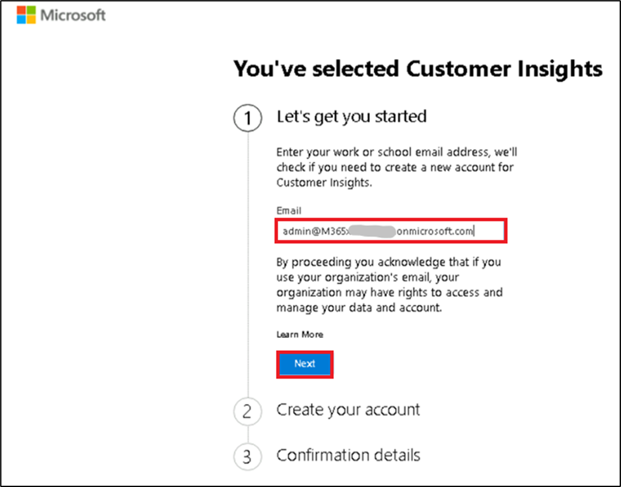

c. Select **Sign in**.

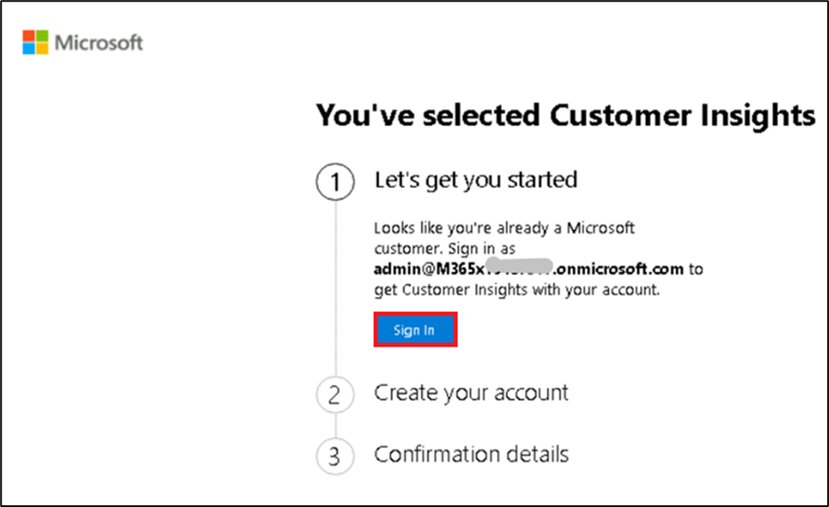

d. Enter **Country/region** as **United States**, your **job title** and **phone number**. Then select **Get Started**.

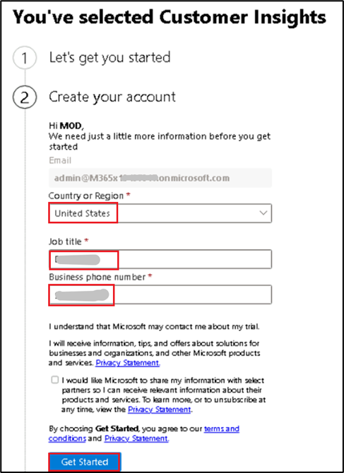

e. Select **Get Started**.

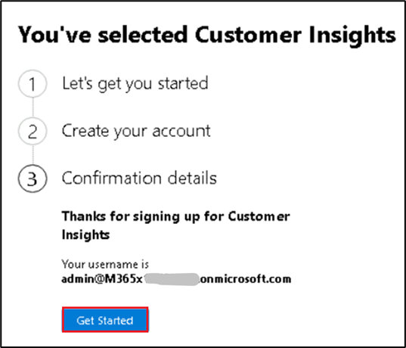

f. You will be on the **Home** page of **Customer Insights – Data** portal. Now, select **Start trial**.

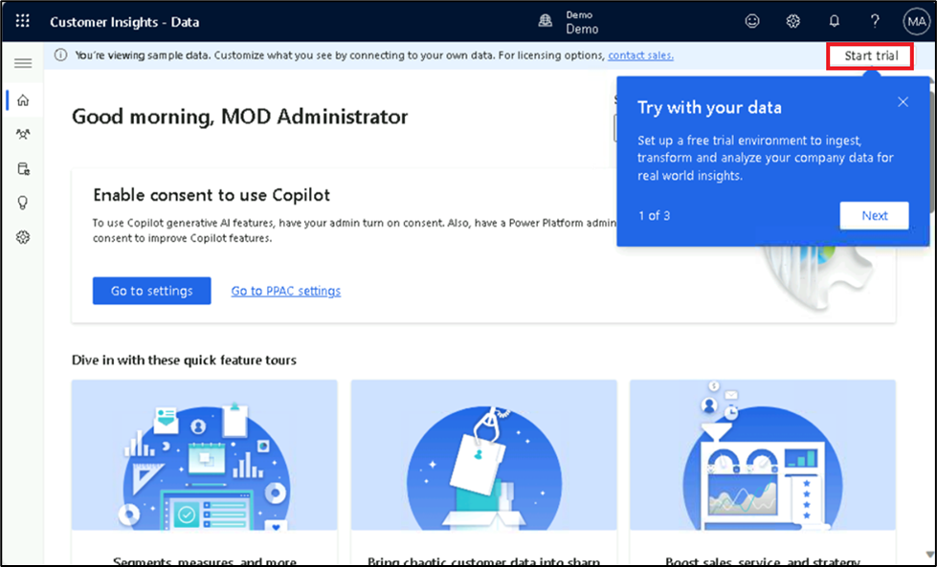

1. You can see that the **Marketing Trial** environment is getting created for you and now you can directly go to step no 14. In case the environment is not created and asking for **Basic information,** then enter [**Marketing Trial**](urn:gd:lg:a:send-vm-keys) in the **Name** field, select **United States** for the **Region** field, and then select **Next**.

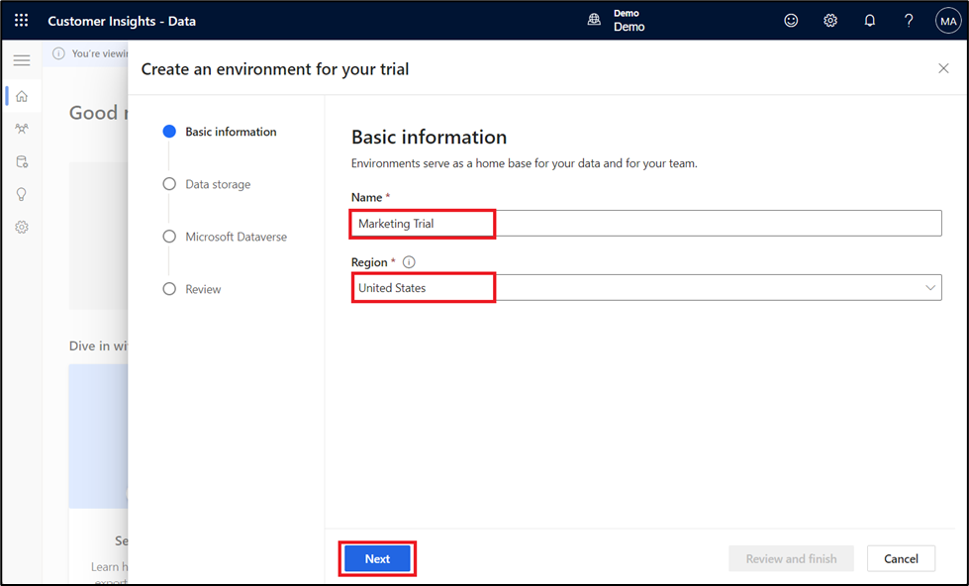

1. Select **Next** on the **Data storage** page.

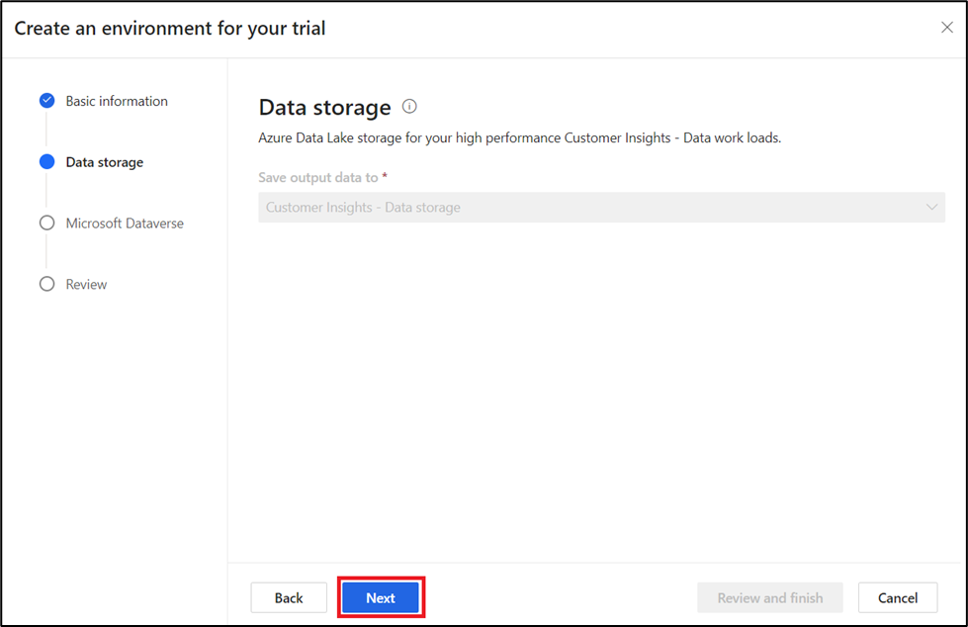

1. Select your **Dataverse environment** and then click **Next**.

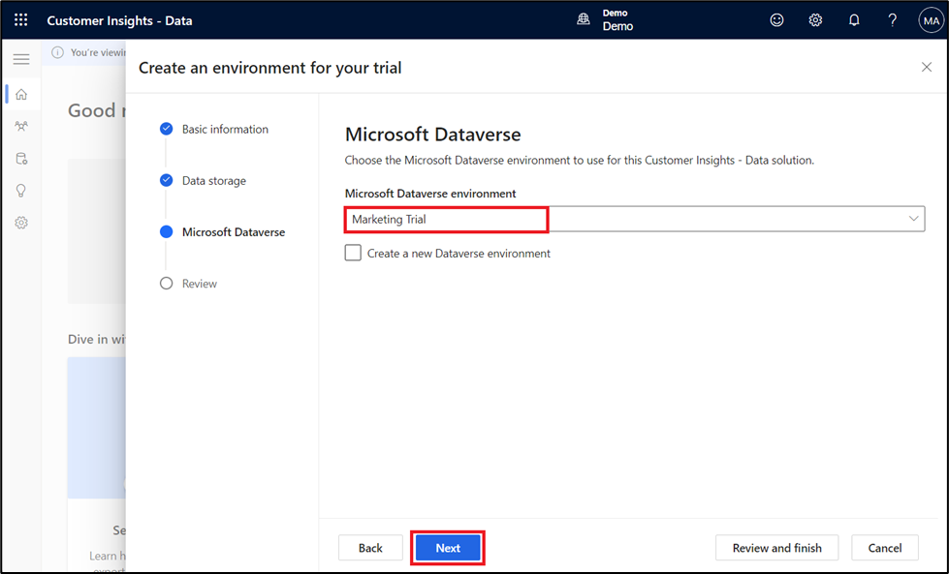

1. Review the information on the **Review** page and then select **Create**.

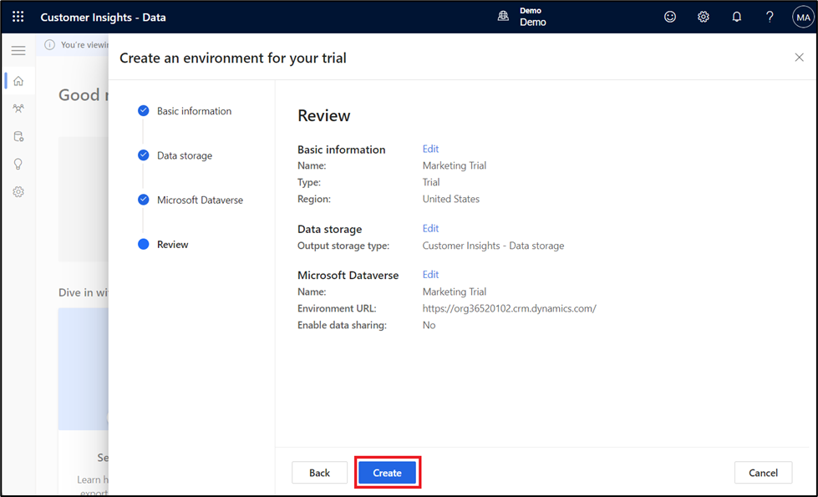

1. It may take some time to create your environment.

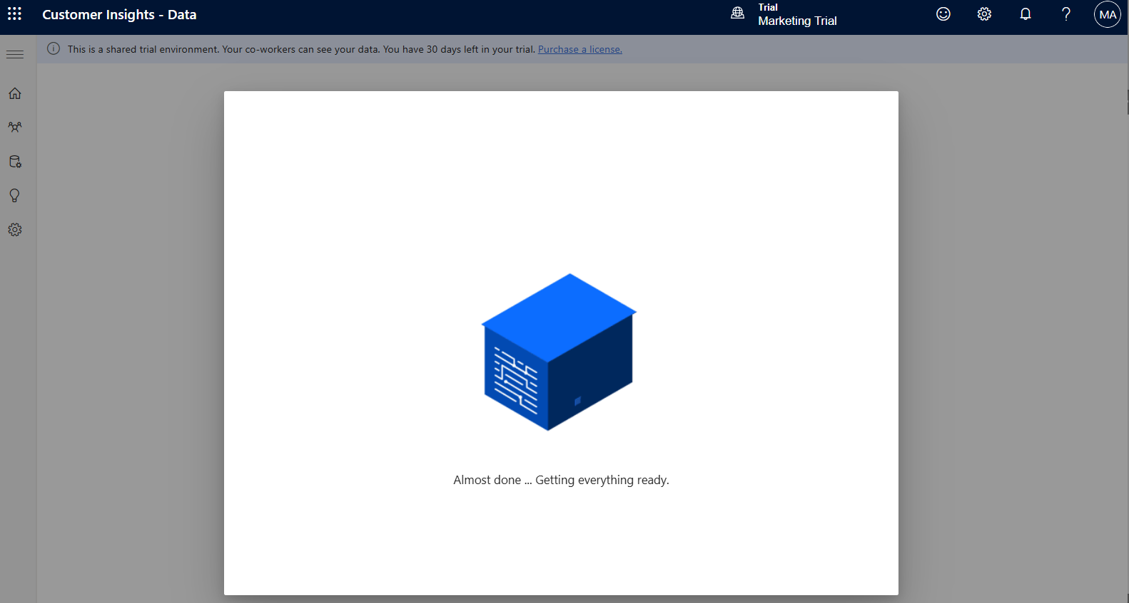

1. You can now see that your environment is named  **Marketing Trial**.

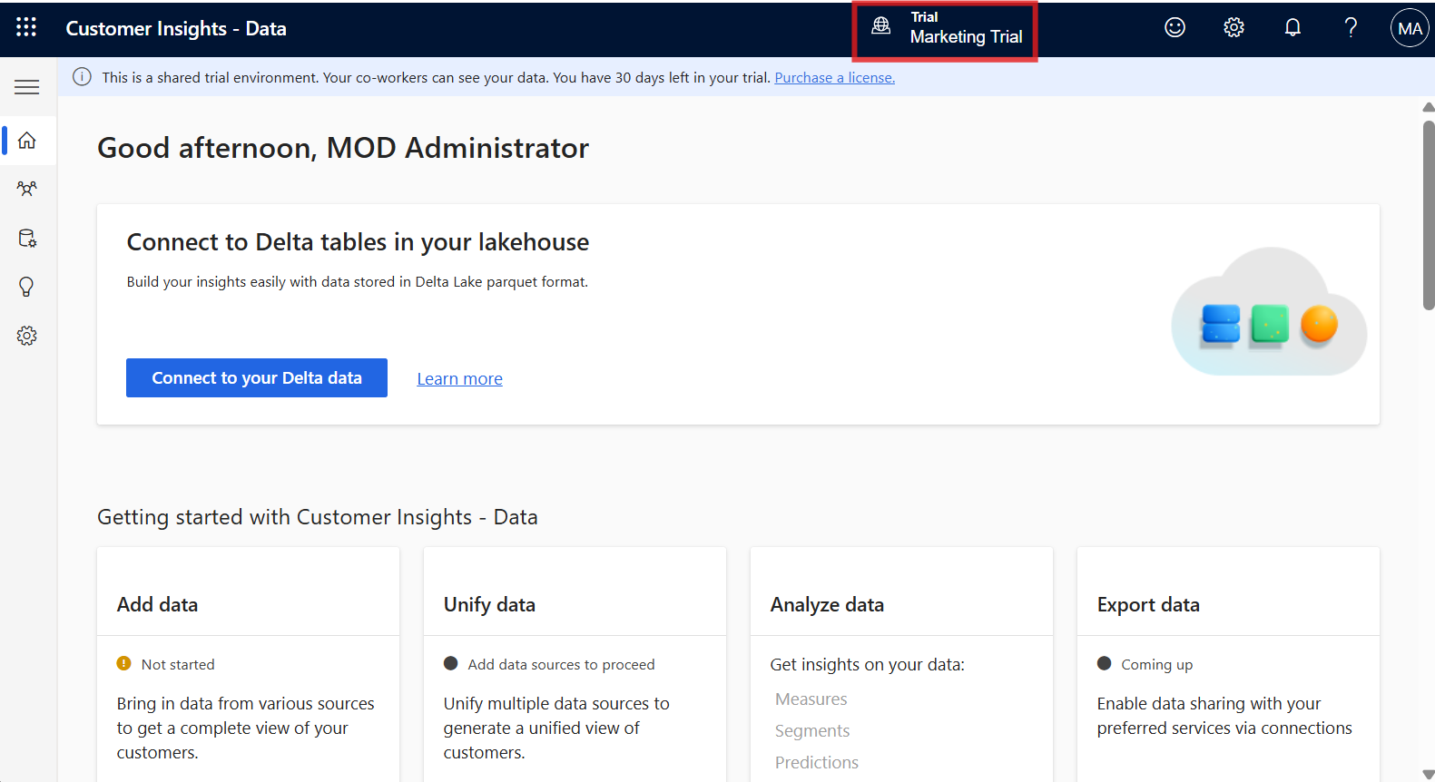

### **Task 2: Give consent to use Copilot in Customer Insights - Data**

1. From the left navigation pane, select **Settings** > **System**.

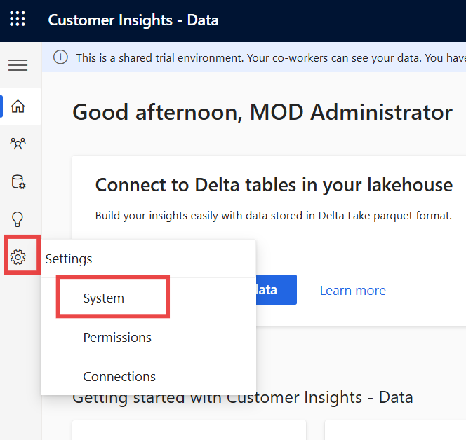

1. Select the **Consent** tab.

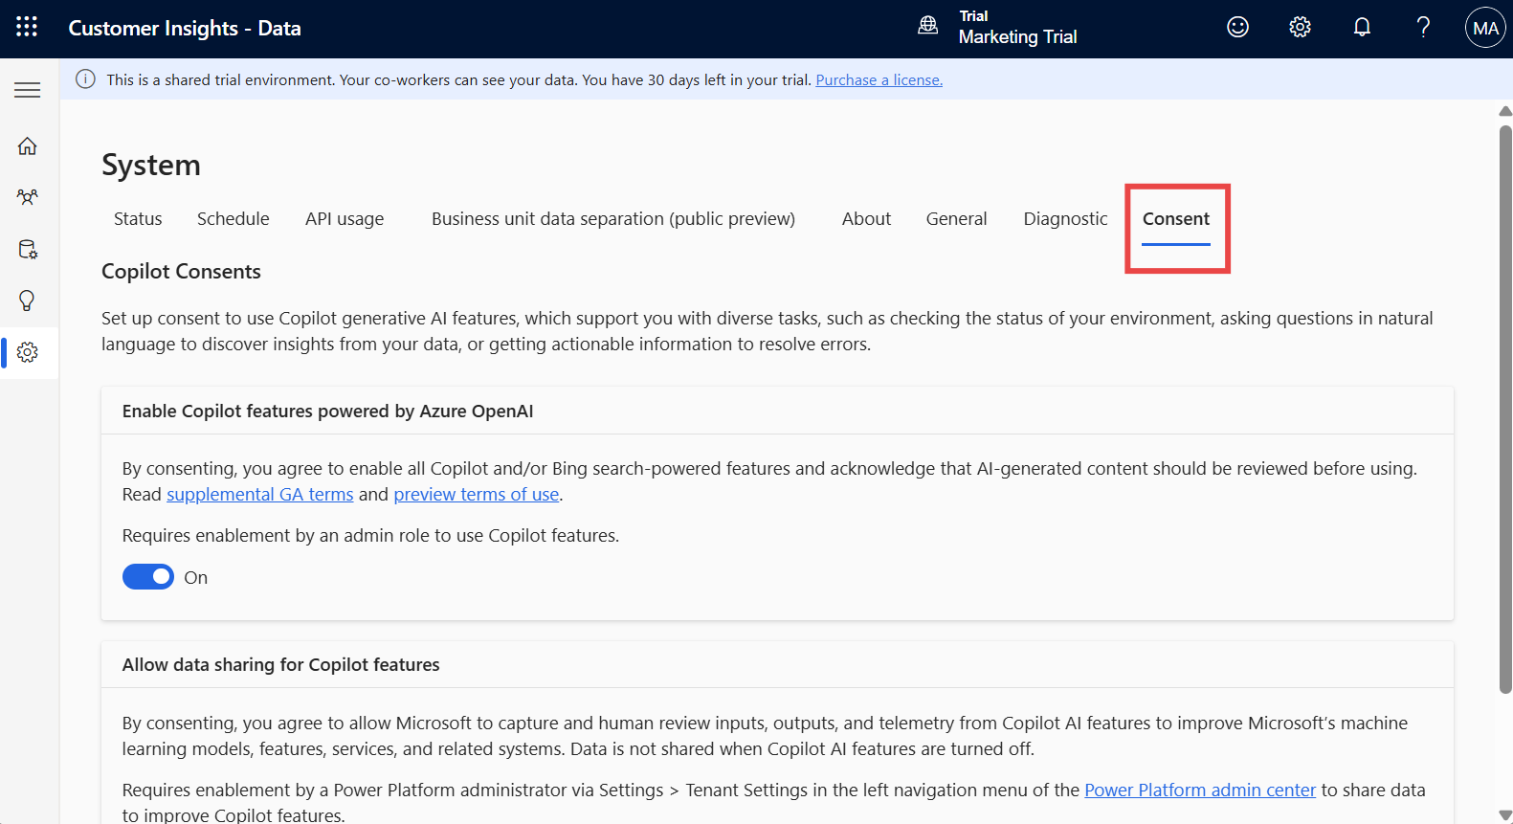

1. **Enable** the **Enable Copilot features powered by Azure OpenAI** and then select **Save**. Ignore if the switch is enabled already.

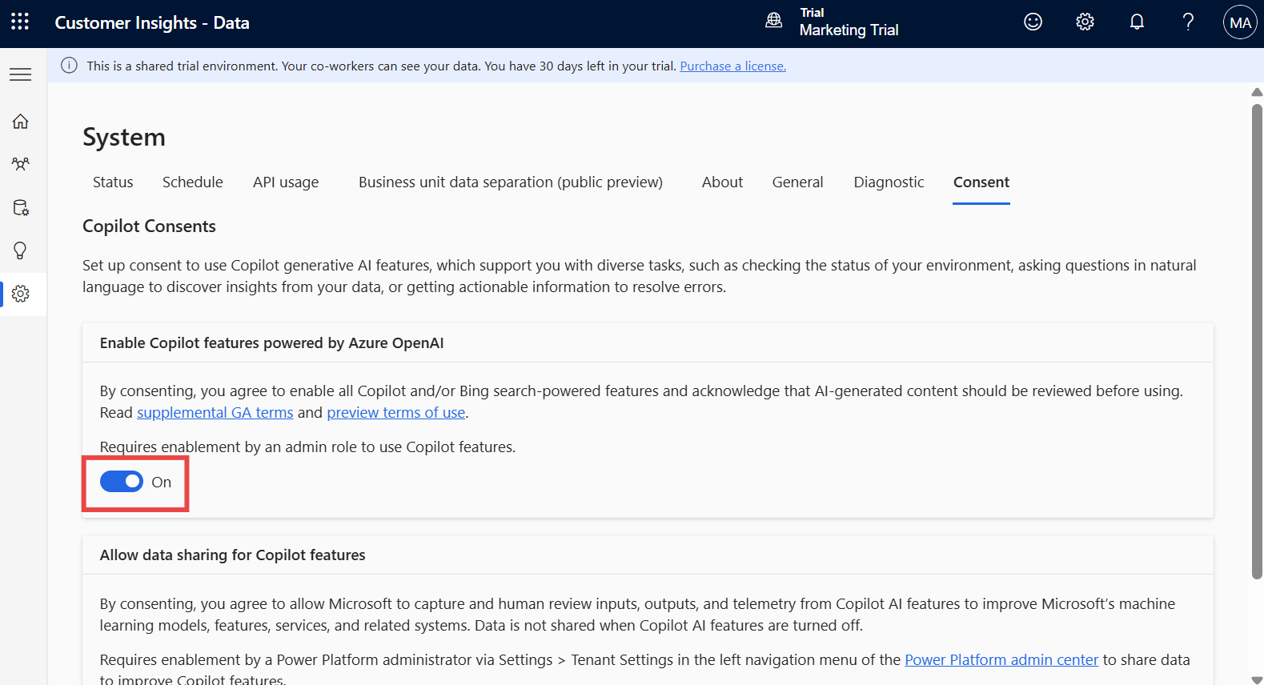

**Note**: It may take some time for the app to appear in the Customer Service - Data portal.

**Summary**: In this lab, you acquired a Power Apps trial license and created a team in Microsoft Teams.